UNIT I
Evolution of HRM

HISTORY OF HRM

- The Industrial revolution
- Rapid technological change and increased specialisation.
- Increased mechanisation and specialisation made jobs routine and monotonous.
- Labour was looked upon as a commodity.
- State did little to protect the workers.

- Trade Unionism
- Workers formed their union to improve their lot.
- Union used strikes, slowdowns, walkouts, picketing, boycotts and sabotage.
- Trade union gave rise to several personnel practices eg. Collective bargaining, grievance handling system, arbitration, disciplinary practices, employee benefit programmes etc.

- Scientific Management
F.W.Taylor developed four principles of scientific management.
- Development of true science.
- Scientific selection and training of workers.
- Friendly cooperation between management and workers.
- Development of every worker to his fullest potential.
- It led to professionalization of management, human engineering etc.
- But focus of scientific management was more on technology and not on human factor in industry.

- Industrial Psychology
- Stressed on employee skills with jobs.
- Contributed significantly to analysis jobs in term of their mental and emotional requirements and development of testing devices.

- Human Relation Movement
- Hawthorne experiment and subsequent research focused attention on the attitudes and feelings of workers and their influence on productivity.
- Role of informal group was highlighted.
- It suggested personal relations should be improved to realise fuller potential of individuals and groups.

- Behavioural Science
- It led to the development of new techniques of motivation and leadership eg. Job enrichment, employee participation, two way communication, MBO etc.

- Human resource Specialist and Employee Welfare
- It manages employee benefit programmes and industrial relations system in industry.

Evolution of the concept of Human Resource management
Modern concept of human resource management has developed through the following stages.
- The commodity concept-
- Guild system was the beginning of human resource management.
- Guild was a closely knit group concerned with selecting, training, rewarding and maintaining workers.

- The factor of Production Concept-
- Taylors scientific management stressed proper selection and training of employees so as to maximise productivity.

- The Paternalistic Concept-
- Employers assumed a protective attitude towards their employees.
- The welfare schemes included health facilities, recreation facilities, pension plans, group insurance schemes, housing facilities etc.
- Employer and employee both began to realise that they cannot survive and prosper without each other.

- The Humanitarian Concept-
- Approach is based on the belief that employees had certain inalienable rights as human being and it was the duty of the employer to protect these rights.

- The Human resource Concept-
- Employees began to be considered as valuable assets of an organisation.
- Focus shifted towards management practices like two way communication, management by objective, role of informal groups, quality circles.

- The Emerging Concept-
- Workers representative are being appointed on the board of directors.
- Employees are look upon as resource, an assets and an opportunity.
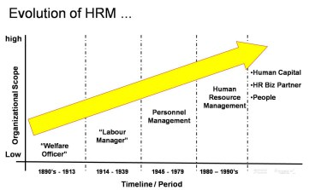

Table 2.1: Evolution and Development of HRM in India:

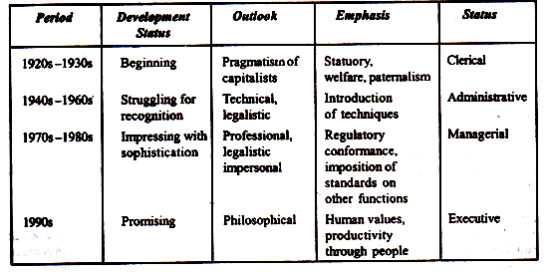

HRM in India: An Overview:
Now that we have delineated the evolution of the concept of HRM, we are prepared to outline an overview of HRM in India. Like UK and USA, the evolution and development of HRM in India was not voluntary. The aftermath of the First World War rendered the country with difficult conditions. These manifested in various malpractices in the recruitment of workers and payment of wages leading to trade unionism in organisations causing colossal loss in production due to industrial disputes.
Given such scene, government intervened under compulsions to take care of the situation. The Royal Commission of Labour in India, in 1931, under the chairmanship of J.H. whitley recommended the abolition of the ‘jobber’ system and the appointment of labour officers in industrial enterprises to deal with the recruitment of labour and to settle their grievances.
After Independence, the Factories Act, 1948 laid down qualifications and duties of Welfare Officers and also made it mandatory for companies employing 500 or more workers to appoint Welfare Officers with requisite qualifications and training.

Definitions of Human Resource Management (HRM)
Human Resource Management (HRM) is concerned with the “people” dimension in management. Since every organisation is made up of people, acquiring their services, developing their skills, motivating them to high level of performance and ensuring that they continue to maintain their commitment to the Organisation are essential to achieving organizational objectives. This is true regardless of type of Organisation Government, business, education, health, recreation or social action. Those organisations that are able to acquire, develop, stimulate and keep outstanding workers will be both effective, able to achieve their goals, and efficient (expanding the least amount of resources necessary). Those organisations that are inefficient and ineffective risk the hazards of stagnating or going out of business.
Human Resource Management (HRM) is an operation in companies designed to maximize employee performance in order to meet the employer's strategic goals and objectives. More precisely, HRM focuses on management of people within companies, emphasizing on policies and systems.
In short, HRM is the process of recruiting, selecting employees, providing proper orientation and induction, imparting proper training and developing skills.

HRM also includes employee assessment like performance appraisal, facilitating proper compensation and benefits, encouragement, maintaining proper relations with labour and with trade unions, and taking care of employee safety, welfare and health by complying with labour laws of the state or country concerned.

Features of HRM
Human Resource Management as a discipline includes the following features −
- It is pervasive in nature, as it is present in all industries.
- It focuses on outcomes and not on rules.
- It helps employees develop and groom their potential completely.
- It motivates employees to give their best to the company.
- It is all about people at work, as individuals as well as in groups.
- It tries to put people on assigned tasks in order to have good production or results.
- It helps a company achieve its goals in the future by facilitating work for competent and well-motivated employees.
- It approaches to build and maintain cordial relationship among people working at various levels in the company.
Basically, we can say that HRM is a multi-disciplinary activity, utilizing knowledge and inputs drawn from psychology, economics, etc.

Objectives:
The primary objective of HRM is to ensure the availability of right people for right jobs so as the organisational goals are achieved effectively.
This primary objective can further be divided into the following sub-objectives:
1. To help the organisation to attain its goals effectively and efficiently by providing competent and motivated employees.
2. To utilize the available human resources effectively.
3. To increase to the fullest the employee’s job satisfaction and self-actualisation.
4. To develop and maintain the quality of work life (QWL) which makes employment in the organisation a desirable personal and social situation.
5. To help maintain ethical policies and behaviour inside and outside the organisation.
6. To establish and maintain cordial relations between employees and management.
7. To reconcile individual/group goals with organisational goals.
Werther and Davis have classified the objectives of HRM into four categories as shown in table 1.2.

Table 1.2: HRM Objectives and Functions:
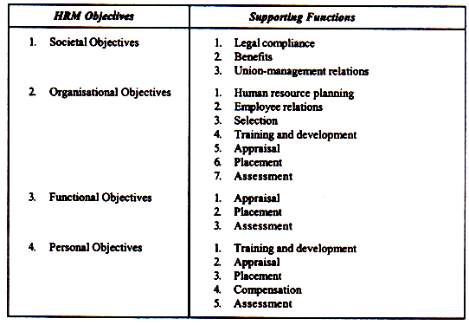

Functions:
We have already defined HRM. The definition of HRM is based on what managers do. The functions performed by managers are common to all organizations. For the convenience of study, the function performed by the resource management can broadly be classified into two categories, viz.
(1) Managerial functions, and
(2) Operative functions

(1) Managerial Functions:
Planning:
Planning is a predetermined course of actions. It is a process of determining the organisational goals and formulation of policies and programmes for achieving them. Thus planning is future oriented concerned with clearly charting out the desired direction of business activities in future. Forecasting is one of the important elements in the planning process. Other functions of managers depend on planning function.

Organising:
Organising is a process by which the structure and allocation of jobs are determined. Thus organising involves giving each subordinate a specific task establishing departments, delegating authority to subordinates, establishing channels of authority and communication, coordinating the work of subordinates, and so on.
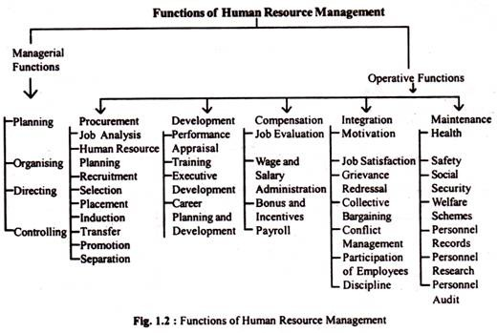
Staffing:
It is a process by which managers select, train, promote and retire their subordinates This involves deciding what type of people should be hired, recruiting prospective employees, selecting employees, setting performance standard, compensating employees, evaluating performance, counselling employees, training and developing employees.
Directing/Leading:
Directing is the process of activating group efforts to achieve the desired goals. It includes activities like getting subordinates to get the job done, maintaining morale motivating subordinates etc. for achieving the goals of the organisation.
Controlling:
It is the process of setting standards for performance, checking to see how actual performance compares with these set standards, and taking corrective actions as needed.

(2) Operative Functions:
The operative, also called, service functions are those which are relevant to specific department. These functions vary from department to department depending on the nature of the department Viewed from this standpoint, the operative functions of HRM relate to ensuring right people for right jobs at right times. These functions include procurement, development, compensation, and maintenance functions of HRM.
Procurement:
It involves procuring the right kind of people in appropriate number to be placed in the organisation. It consists of activities such as manpower planning, recruitment, selection placement and induction or orientation of new employees.
Development:
This function involves activities meant to improve the knowledge, skills aptitudes and values of employees so as to enable them to perform their jobs in a better manner in future. These functions may comprise training to employees, executive training to develop managers, organisation development to strike a better fit between organisational climate/culture and employees.
Compensation:
Compensation function involves determination of wages and salaries matching with contribution made by employees to organisational goals. In other words, this function ensures equitable and fair remuneration for employees in the organisation. It consists of activities such as job evaluation, wage and salary administration, bonus, incentives, etc.
Maintenance:
It is concerned with protecting and promoting employees while at work. For this purpose virus benefits such as housing, medical, educational, transport facilities, etc. are provided to the employees. Several social security measures such as provident fund, pension, gratuity, group insurance, etc. are also arranged.
It is important to note that the managerial and operative functions of HRM are performed in conjunction with each other in an organisation, be large or small organisations. Having discussed the scope and functions of HRM, now it seems pertinent to delineate the HRM scenario in India.

Personnel Management v/s Human Resource Management

1) Personnel Management
Personnel are those who are employed in the workplace. Personnel management is an administrative function which exists in an organization to ensure right personnel at right organizational activity. It is a traditional approach of managing employees which focuses on adherence to policies and rules of organization. Personnel management is concerned with planning, job analysis, and recruitment and performance appraisal along with training and compensation management. Personnel management also focuses on managing labour relationship by handling employee grievances.
2) Human Resource Management
Human resource management is a modern approach of managing people at workplace which focuses on acquisition, development, utilization and maintenance of human resource. It combines physical energies and their strengths with human competencies. In simple words, human resource management can be referred as the policy which ensures right quality and quantity of human resource in the organization. Like personnel management, human resource management is also concerned with planning, job analysis, recruitment and selection, hiring and socialization, training, performance appraisal, rewarding, and compensation management.
BASIS OF DIFFERENCE | PERSONNEL MANAGEMENT | Human resource Management
Meaning | It is traditional approach of managing people at workplace and is concern of personnel department. | It is modern approach of managing people at workplace and is concern of managers of all level (from top to bottom).
Nature | It is a routine function. | It is a strategic function.
Focus | Efficient management is given priority. | Human values and individual needs are given priority.
Function | Personnel administration, labour relation and employee welfare are major functions of personnel management. | Acquisition, development, utilization and maintenance of human resource are major functions of human resource management.
Objective | It manages people in accordance with organization’s goal. | It determines human resource needs and formulates policies by matching individual’s needs with organization’s needs.
Perspective | It regards people as basic input to make desired output. | It regards people as strategic and valuable resource to make desired output.
Job design | Jobs are designed on the basis of division of labour. | Jobs are designed on the basis of teamwork.
Interest | Organization’s interest is valued the most. | Interest of organization and interest of employee is harmonized.
Orientation | It is discipline, direction and control oriented. | It is development oriented. It provides space for employee involvement, performance and growth.
Communication | Communication is limited, or even restricted. | Communication is open.
Emphasis | It emphasizes on adherence of rules and regulations and their implementation. | It emphasizes on combination of human energies and competencies.
Benefits | - Disciplined employees  - Increased production | - Committed human resource  - Readiness to change  - Increased production  - Increased profit  - Quality of work life
Result | Organizational goal is achieved and employers are satisfied. | Organizational goal is achieved and both employers and employees are satisfied.

Difference between HRM and SHRM
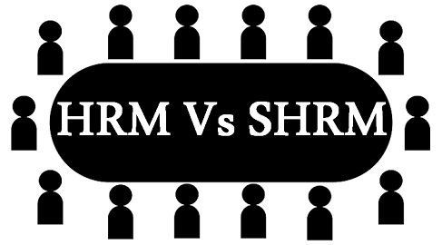
The term HRM expands to Human Resource Management; it implies the implementation of management principles for managing the workforce of an organisation. It is concerned with the process of hiring, developing and retaining the manpower, with a view to making them more efficient. When conventional HRM is compared and contrasted with the strategic HRM or SHRM, it becomes easier to understand.
SHRM is the process of aligning the business strategy with the company’s human resource practices, so as to attain strategic goals of an organization. In SHRM, the workforce of the company is managed proactively.

Comparison Chart
BASIS FOR COMPARISON | HRM | SHRM
Meaning | Human resource management (HRM) implies the governance of manpower of the organization in a thorough and structured manner. | SHRM is a managerial function which implies framing of HR strategies in such a way to direct employees efforts towards the goals of organization.
Nature | Reactive | Proactive
Responsibility lies with | Staff specialist | Line manager
Approach | Fragmented | Integrated
Scope | Concerned with employee relations | Concerned with internal and external relations
Time horizon | Short term | Long term
Basic factor | Capital and products | People and knowledge
Change | Follows change | Initiates change
Accountability | Cost centre | Investment centre
Control | Stringent  control over employees. | It exhibits leniency.

Key Differences between HRM and SHRM
The differences between HRM and SHRM can be drawn clearly on the following grounds:
- The governance of manpower of the organisation in a thorough and structured manner is called Human Resource Management or HRM. A managerial function which implies framing of HR strategies in such a way to direct employee’s efforts towards the goals of an organisation is known as SHRM.
- The process of HRM is reactive in nature. On the other hand, SHRM is a proactive management function.
- In human resource management, the responsibility of manpower lies with the staff specialists, whereas in strategic human resource management, the task of managing the workforce is vested in the line managers.
- HRM follows fragmented approach, which stresses on applying management principles while managing people in an organisation. As against this, SHRM follows an integrated approach, which involves lining up of business strategy with the company’s HR practices.
- Human resource management emphasises on employee relations, ensuring employees motivation, and also the firm conforms to the necessary employment laws. Conversely, SHRM focuses on a partnership with internal and external constituent groups.
- HRM supports short-term business goals and outcomes, but SHRM supports long-term goals and results of business.
- In human resource management, the human resource manager plays the role of change follower, i.e. he/she responses to change, hence pursues transactional leadership style. As opposed to SHRM, the human resource manager is a change leader, i.e. an imitator, thus seeks transformational leadership.
- The primary element in HRM is the capital and products, but people and their knowledge are the building blocks of SHRM.
- If we talk about accountability, a conventional HRM is a cost centre. Unlike a strategic HRM which is an investment centre.
- In human resource management, stringent control over employees is exercised. As against this, in strategic human resource management, no such control is imposed, rather the rules for managing manpower is lenient.

Unit II

Meaning of Human Resource Planning:
HRP has been defined as “the process by which management determines how an organisation should move from its current manpower position to its desired position. Through it management strives to have the right type of people, in the right number, at the right time and place, doing things which result in both the organisation and the individual receiving maximum long range benefits.
According to E.W. Vetter, human resource planning is “the process by which a management determines how an organisation should make from its current manpower position to its desired manpower position.
Objectives of Human Resource Planning are as follows:
- Guarantee ample supply of resources, whenever there is a need for it.
- Make sure that the current manpower in the company is being used properly.
- To foresee the potential requirements of manpower at various skill levels.
- Evaluate excess or scarcity of resources that are available at a given point of time.
- Predict the impact of technological changes on the resources as well as on the kind of jobs they do.
- Manage the resources that are already employed in the organization.
- Ensure that there is a lead time available to pick and train any supplementary human resource.

HUMAN RESOURCE PLANNING PROCESS
The major stages involved in HR planning are: -
- Environmental scanning: -
Helps HR planners identify and anticipate source of problems, threats and opportunities that should drive the organisation strategic planning.
- Economy
- Technology
- Competition
- Labour law
- Demographic and social trends.
- Government regulations.

- Internal review: -
- Vision and strategy
- Organisational plans
- Time horizon
- Current human resources
- Objectives of manpower planning.

- Forecasting Demand for Human Resource(manpower forecasting):- On the basis of the following information, the future needs for human resources in the org. are anticipated :
- Corporate and functional plans
- Future activity levels
- Production technology process
- Production and sales budget
- Projection for mew position to be created.

- Forecasting Supply of Human Resources:-

- Matching demand and supply forecasting: -

- Action Planning and programming: -
- Layoffs
- Downsizing
- Attrition
- Early retirement
- Reduced work hours
- Out placement
- Hiring
- Retraining
- Career management
- Productivity programmes.

- Monitoring and control

Recruitment:

Meaning:
Recruitment is a positive process of searching for prospective employees and stimulating them to apply for the jobs in the organisation. When more persons apply for jobs then there will be a scope for recruiting better persons.
Recruitment is concerned with reaching out, attracting, and ensuring a supply of qualified personnel and making out selection of requisite manpower both in their quantitative and qualitative aspect. It is the development and maintenance of adequate man- power resources. This is the first stage of the process of selection and is completed with placement.

Definition:
According to Edwin B. Flippo, “It is a process of searching for prospective employees and stimulating and encouraging them to apply for jobs in an organisation.” He further elaborates it, terming it both negative and positive.
RECRUITMENT PROCESS
The five steps involved in recruitment process are as follows:
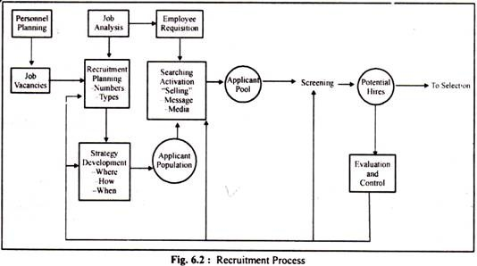

1. Recruitment Planning:
The first step involved in the recruitment process is planning. Here, planning involves to draft a comprehensive job specification for the vacant position, outlining its major and minor responsibilities; the skills, experience and qualifications needed; grade and level of pay; starting date; whether temporary or permanent; and mention of special conditions, if any, attached to the job to be filled”

2. Strategy Development:
Once it is known how many with what qualifications of candidates are required, the next step involved in this regard is to devise a suitable strategy for recruiting the candidates in the organisation.
The strategic considerations to be considered may include issues like whether to prepare the required candidates themselves or hire it from outside, what type of recruitment method to be used, what geographical area be considered for searching the candidates, which source of recruitment to be practiced, and what sequence of activities to be followed in recruiting candidates in the organisation.

3. Searching:
This step involves attracting job seekers to the organisation. There are broadly two sources used to attract candidates.
These are:
1. Internal Sources, and
2. External Sources

4. Screening:
Though some view screening as the starting point of selection but it is considered as an integral part of recruitment. The reason being the selection process starts only after the applications have been screened and shortlisted. Let it be exemplified with an example.
In the Universities, applications are invited for filling the post of Professors. Applications received in response to invitation, i.e., advertisement are screened and shortlisted on the basis of eligibility and suitability. Then, only the screened applicants are invited for seminar presentation and personal interview.
Job specification is invaluable in screening. Applications are screened against the qualification, knowledge, skills, abilities, interest and experience mentioned in the job specification. Those who do not qualify are straightway eliminated from the selection process.

5. Evaluation and Control:
Given the considerable cost involved in the recruitment process, its evaluation and control is, therefore, imperative.
The costs generally incurred in a recruitment process include:
(i) Salary of recruiters
(ii) Cost of time spent for preparing job analysis, advertisement
(iii) Administrative expenses
(iv) Cost of outsourcing or overtime while vacancies remain unfilled
(v) Cost incurred in recruiting unsuitable candidates
Method of recruitment
1. Direct Method
2. Indirect Method
3. Third Party Method
4. Internet recruitment
Selection:
Finding the interested candidates who have submitted their profiles for a particular job is the process of recruitment, and choosing the best and most suitable candidates among them is the process of selection. It results in elimination of unsuitable candidates. It follows scientific techniques for the appropriate choice of a person for the job.
The recruitment process has a wide coverage as it collects the applications of interested candidates, whereas the selection process narrows down the scope and becomes specific when it selects the suitable candidates.
Stone defines, ‘Selection is the process of differentiating between applicants in order to identify (and hire) those with a greater likelihood of success in a job

Steps Involved in Selection Procedure:

  - Preliminary interview
  - Application blanks
  - Selection test
  - Employment interview
  - Medical examination
  - Reference checks
  - Final approval

JOB ANALYSIS

MEANING -
Job analysis is a formal and detailed study of jobs. It refers to a scientific and systematic analysis of a job in order to obtain all pertinent facts about the jobs.

According to Jones and Deco this “Job analysis is the process of getting information about jobs: specially, what the worker does; how he gets it done; why he does it; skill, education and training required; relationship to other jobs, physical demands; environmental conditions”.

Job Analysis is a process of collecting information about a job. The process of job analysis results into two sets of data.
- Job Description
- Job Specification

Process of job analysis:

  - Organisational Job Analysis:
  - Organising job analysis programme
  - Deciding the uses of job analysis information
  - Selecting representatives’ jobs for analysis
  - Understand job design
  - Collection of data
  - Developing a job description
  - Preparing a job specification

Mark organisational analysis

Prepare job analysis programme

Decide uses

Select job analysis

Types of data methods of data
Data collection agent
Gather information
Process Information

Develop job description
Uses and applications
Develop Job Specification

Fig. process of job analysis
Techniques of Job Analysis (methods)-
- Job performance
- Personal observation
- Interview
- Questionnaire
- Critical incident
- Log records

Job Description:
Job description is prepared on the basis of data collected through job analysis. Job description is a functional description of the contents what the job entails. It is a narration of the contents of a job. It is a description of the activities and duties to be performed in a job, the relationship of the job with other jobs, the equipment and tools involved, the nature of supervision, working conditions and hazards of the job and so on.
All major categories of jobs need to be spelled out in clear and comprehensive manner to determine the qualifications and skills required to perform a job. Thus, job description differentiates one job from the other. In sum, job description is a written statement of what a job holder does, how it is done, and why it is done
Purposes of Job Description:

1. Grading and classification of jobs
2. Placement and Orientation of new employees
3. Promotions and transfers
4. Outlining for career path
5. Developing work standards
6. Counselling of employees
7. Delimitation of authority

Job Specification:
While job description focuses on the job, job specification focuses on the person i.e, the job holder. Job specification is a statement of the minimum levels of qualifications, skills, physical and other abilities, experience, judgment and attributes required for performing job effectively. In other words, it is a statement of the minimum acceptable qualifications that an incumbent must possess to perform a given job. It sets forth the knowledge, skills and abilities required to do the job effectively.
Job specification specifies the physical, psychological, personal, social and behavioural characteristics of the job holders. These contents of the job specification are contained in Table 5.1.
Usages of Job Specification: The usages of job specification include:
1. Personnel planning
2. Performance appraisal
3. Hiring
4. Training and development
5. Job evaluation and compensation
6. Health and safety
7. Employee discipline
8. Work scheduling
9. Career planning

Contents of Job Description and Job Specification:
The contents of job description and job specification are presented in the following Table 5.1.

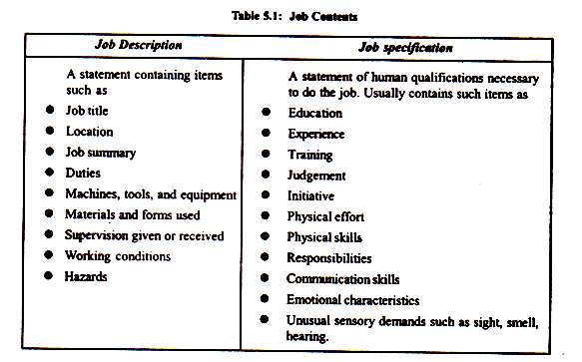

UNIT III

Meaning of Training:
“Training is the act of increasing the knowledge and skills of an employee for doing a particular job.” — Edwin B. Flippo
Training is an organized activity for increasing the technical skills of the employees to enable them to do particular jobs efficiently. In other words, training provides the workers with facility to gain technical knowledge and to learn new skills to do specific jobs. Training is equally important for the existing as well as the new employees. It enables the new employees to get acquainted with their jobs and also increase the job-related knowledge and skills.

Objectives of Training:

(i) To provide job related knowledge to the workers.
(ii) To impart skills among the workers systematically so that they may learn quickly.
(iii) To bring about change in the attitudes of the workers towards fellow workers, supervisor and the organization.
(iv) To improve the productivity of the workers and the organization.
(v) To reduce the number of accidents by providing safety training to the workers,
(vi) To make the workers handle materials, machines and equipment efficiently and thus to check wastage of time and resources.
(vii) To prepare workers for promotion to higher jobs by imparting them advanced skills.

Need and Importance of Training:

  - Higher Productivity
  - Quality Improvement
  - Reduction of Learning Time
  - Industrial Safety
  - Reduction of Turnover and Absenteeism
  - Technology Update
  - Effective Management
  - Reduced supervision
  - Job satisfaction
Approaches/Types of training

Stages in training:-

Stage 1:-
Assessment method
- Organisational weakness
- Departmental weaknesses
- Job specifications and employee specification
- Identifying specific problems
- Anticipating future problems.
- Interview.
Training Content
- Supervisory training
- Sales training
- Clerical training
- Learning and teaching.
SATGE 2:-
Instructional objectives- specify the skills, knowledge, talents and competency to be acquired, attitude, values and beliefs to be changed and behaviour to be modifies.
- Learning principles-
- Appropriate material (case studies, tools, problems etc).
- Learning ids active and not passive.
- Learning is cumulative process.
- Learning Patterns-
Learners Job proficiency
Discouraging Increasing False Peak Over-learning
First stage returns plateau productivity period

Training Time

- Principles of training-
- Motivation
- Progress information
- Reinforcement
- Practice
- Full vs. Part
- Individual differences

- Areas of training
- Company policies and procedure
- Specific skills
- Human relations
- Apprentice training.
STAGE 3-
TRAINING METHODS

On-the –job methods Off- the jobs- methods
- Vestibule training
- Role playing
- Lecture methods
- Conference or Discussion
- Programmed Instructions
- Audio-Visual methods
- Computer based training and e-learning.
- Job rotation
- Coaching
- Job Instruction
- Training through Step-by- step
- Committee Assignments
- Internship training

Methods of Training:

1. On-the-job Training (OJT) Methods:
This is the most common method of training in which a trainee is placed on a specific job and taught the skills and knowledge necessary to perform it.

The advantages of OJT are as follows:
1. On the job method is a flexible method
2. It is a less expensive method.
3. The trainee is highly motivated and encouraged to learn.
4. Much arrangement for the training is not required.

On-the-job training methods are as follows:

1. Job rotation:

2. Coaching:

3. Job instructions:

4. Committee assignments:

5. Internship training:

2. Off-the-job Methods/vestibule training:
On the job training methods have their own limitations, and in order to have the overall development of employee’s off-the-job training can also be imparted. The methods of training which are adopted for the development of employees away from the field of the job are known as off-the-job methods.
The following are some of the off-the-job techniques:

1. Case study method:

2. Incident method

3. Role play:

4. Lectures

5. Simulation

6. Conferences etc

STAGE 4- Evaluation of Training programme-

- Reactions
- Learning
- Job behaviour
- Organisation
- Ultimate value

- Essentials ingredients for a Successful Evaluation-
- General observations
- Human resource factors
- Performance tests
- Feedback

Methods of evaluation-
- Opinion and judgements of trainers.
- Asking trainees to fill up the evaluation forms.
- Using questionnaire to know the reactions of trainees.
- Arranging structured interview with the trainees.
- Comparing trainee’s performance on-the-job and after training.
- Measuring level of productivity, wastage costs, and absenteeism.
- Cost benefits analysis of the training programme.

UNIT IV

Performance Appraisal
Performance appraisal is the process of assessing the performance and progress of an employee or a group of employees on a given job and his potential for future development.
The main objective of performance appraisal is to improve the efficiency of a concern by mobilising the best possible efforts from individuals employed in it.

Definition:
Performance appraisal is a systematic, periodic and so far, as humanly possible, the impartial rating of an employee’s excellence in matters pertaining to his present job and to his potentialities for a better job.”—Edwin B, Flippo
Dale S. Beach, "Performance appraisal is systematic evaluation of the individual with respect to his or her performance on the job and his or her potential for development".
Objectives of Performance appraisal:
- To review the performance of the employees over a given period of time.
- To judge the gap between the actual and the desired performance.
- To help the management in exercising organizational control.
- Helps to strengthen the relationship and communication between superior – subordinates and management – employees.
- To diagnose the strengths and weaknesses of the individuals so as to identify the training and development needs of the future.
- To provide feedback to the employees regarding their past performance.
- Provide information to assist in the other personnel decisions in the organization.
- Provide clarity of the expectations and responsibilities of the functions to be performed by the employees.
- To judge the effectiveness of the other human resource functions of the organization such as recruitment, selection, training, and development.
- To reduce the grievances of the employees.

Process of Performance Appraisal

1. Establish Performance Standards:
The appraisal process begins with the establishment of performance standards. The managers must determine what outputs, accomplishments and skills will be evaluated. These standards should have evolved out of job analysis and job descriptions.

2. Communicate Performance Expectations to Employees:
Once the performance standards are established, this need to be communicated to the respective employees so that they come to know what is expected of them. Past experience indicates that not communicating standards to the employees compounds the appraisal problem.
The feedback from the employees on the standards communicated to them must be obtained.

3. Measure Actual Performance:
This is the third step involved in the appraisal process. In this stage, the actual performance of the employee is measured on the basis of information available from various sources such as personal observation, statistical reports, oral reports, and written reports.

4. Compare Actual Performance with Standards:
In this stage, the actual performance is compared with the predetermined standards. Such a comparison may reveal the deviation between standard performance and actual performance.

5. Discuss the Appraisal with the Employee: The fifth step in the appraisal process is to communicate to and discuss with the employees the results of the appraisal. This is, in fact, one of the most challenging tasks the manager’s face to present an accurate appraisal to the employees and then make them accept the appraisal in a constructive manner.
A discussion on appraisal enables employees to know their strengths and weaknesses. This has, in turn, impact on their future performance.

6. Initiate Corrective Action:
The final step in the appraisal process is the initiation of corrective action when it is necessary. The areas needing improvement are identified and then, the measures to correct or improve the performance are identified and initiated.
The corrective action can be of two types. One is immediate and deals predominantly with symptoms. This action is often called as “putting out fires.” The other is basic and delves into causes of deviations and seeks to adjust the difference permanently.
Setting performance standards

Communicating standards
Taking corrective actions
Discussing results
Comparing the standards
Measuring performance

Fig. process of performance appraisal

Obstacles in Performance Appraisal:
Every organization undertakes performance appraisal, either formally or informally. There are certain barriers, which work against effective appraisal systems.

These barriers have been grouped into three categories:
1. Faulty assumptions.
2. Psychological blocks.
3. Technical pitfalls.

1. Faulty Assumptions:
The germinating faulty assumptions between the superior and the subordinate create problems during the appraisal.

2. Psychological Blocks:
The value of any tool lies on the skills of the user. Therefore the utility of performance appraisal depends upon the psychological characteristics of the managers.
These are like:
i) Feeling of insecurity.
ii) Considering appraisal as an extra burden.
iii) Being excessively modest or sceptical.
iv) Feeling to treat subordinates failures as their deficiency.
v) Disliking of resentment by subordinates.

3. Technical Pitfalls:
The main technical, difficulties in appraisal fall into two main categories the criterion problem and distortions
Criterion problem:
A criterion is the standard of performance the manager desires of his subordinates and against which he compares their actual performance. Criteria are hard to define in measurable term or objective term. Ambiguity, vagueness and generality of criteria are difficult hurdles for any process to overcome.
Distortions:
Distortions occur in form of biasness and errors in making the evaluation.
An appraisal system has the following distortions: -
- Halo effect

(ii) Central Tendency

(iii) First Impression (Primacy effect)

(iv) Horn effect

(v) Constant errors

(vi) Raters liking and disliking
(vii) Stereotyping
(x) Recency effect
(xi) Poor Appraisal forms

Performance Appraisal Methods: Traditional and Modern Methods
The various methods included in each of the two categories are listed in Table 28.4.
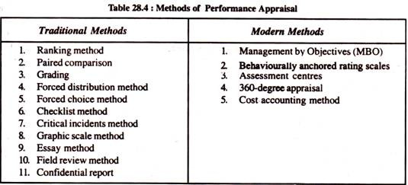.

Traditional Methods:

Ranking Method:
It is the oldest and simplest formal systematic method of performance appraisal in which employee is compared with all others for placing order of worth. The employees are ranked from the highest to the lowest or from the best to the worst

Paired Comparison:
In this method, each employee is compared with other employees on one- on one basis, usually based on one trait only.

Grading Method:
There can be three categories established for employees: outstanding, satisfactory and unsatisfactory. There can be more than three grades. Employee performance is compared with grade definitions. The employee is, then, allocated to the grade that best describes his or her performance.

Forced Distribution Method:
This method was evolved by Tiffen to eliminate the central tendency of rating most of the employees at a higher end of the scale.

Forced-Choice Method:
The forced-choice method is developed by J. P. Guilford. It contains a series of groups of statements, and rater rates how effectively a statement describes each individual being evaluated. Common method of forced-choice method contains two statements, both positive and negative.

Check-List Method:
The basic purpose of utilizing check-list method is to ease the evaluation burden upon the rater. In this method, a series of statements, i.e., questions with their answers in ‘yes’ or ‘no’ are prepared by the HR department .The check-list is, then, presented to the rater to tick appropriate answers relevant to the appraise

Critical Incidents Method:
In this method, the rater focuses his or her attention on those key or critical behaviours that make the difference between performing a job in a noteworthy manner.

Graphic Rating Scale Method:
In this method, the printed appraisal form is used to appraise each employee. The rating is done on the basis of points on the continuum. The common practice is to follow five points scale.

Essay Method:
Essay method is the simplest one among various appraisal methods available. In this method, the rater writes a narrative description on an employee’s strengths, weaknesses, past performance, potential and suggestions for improvement.

Field Review Method:
When there is a reason to suspect rater’s biasedness or his or her rating appears to be quite higher than others, these are neutralised with the help of a review process. The review process is usually conducted by the personnel officer in the HR department.

Confidential Report:
It is the traditional way of appraising employees mainly in the Government Departments. Evaluation is made by the immediate boss or supervisor for giving effect to promotion and transfer.

Modern Methods:
- Management by Objectives (MBO):
MBO requires the manager to goals with each employee and then periodically discuss his or her progress toward these goals.

2. Behaviourally Anchored Rating Scales (BARS):
BARS are descriptions of various degrees of behaviour with regard to a specific performance dimension.
It combines the benefits of narratives, critical incidents, and quantified ratings by anchoring a quantified scale with specific behavioural examples of good or poor performance.

3. 360 – Degree Appraisal:
In 360-degree feedback appraisal system, an employee is appraised by his supervisor, subordinates, peers, and customers with whom he interacts in the course of his job performance. All these appraisers provide information or feedback on an employee by completing survey questionnaires designed for this purpose.

- Cost Accounting Method:
This method evaluates an employee’s performance from the monetary benefits the employee yields to his/her organisation.
- Assessment Centres:
In business field, assessment centres are mainly used for evaluating executive or supervisory potential. By definition, an assessment centre is a central location where managers come together to participate in well-designed simulated exercises.
Career Planning

Career planning is the systematic process by which one selects career goals and the path to these goals. From the organisational viewpoint it means, helping the employees to plan their career in terms of their capacities within the context of organisations needs.

Objectives of Career Planning:
1. To identify positive characteristics of the employees.
2. To develop awareness about each employee’s uniqueness.
3. To respect feelings of other employees.
4. To attract talented employees to the organization.
5. To train employees towards team-building skills.
6. To create healthy ways of dealing with conflicts, emotions, and stress.

Benefits of Career Planning:
1. Career planning ensures a constant supply of promotable employees.
2. It helps in improving the loyalty of employees.
3. Career planning encourages an employee’s growth and development.
4. It discourages the negative attitude of superiors who are interested in suppressing the growth of the subordinates.
5. It ensures that senior management knows about the calibre and capacity of the employees who can move upwards.
6. It can always create a team of employees prepared enough to meet any contingency.
7. Career planning reduces labour turnover.
8. Every organization prepares succession planning towards which career planning is the first step.

Process of Career planning
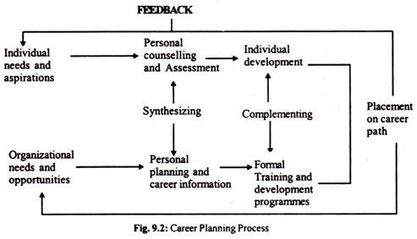
Steps of Career planning: -
- Identifying individual needs and aspirations-
- Analysing career opportunities
- Identifying match and mismatch
- Formulating and implementing strategies
- Reviewing career plans

Career Development

Career Development is defined as the efforts that are made by the organization to equip its employees with the skills, knowledge & experience that help them to perform the duties of their current as well as future jobs effectively. The organization develops and implements certain policies including counseling the employees, promotion & opportunities to attain excellence that facilitate the employee to prepare their career.
Definition-
According to Schuler, "It is an activity to identify the individual needs, abilities and goals and the organization’s job demands and job rewards and then through well designed programmes of career development matching abilities with demands and rewards.
Career development involves following activities: -
- Career need Assessment- Career needs of employees can be judged by evaluating their aptitudes, abilities and potential. The organisation should assist employees in assessing their career needs and in identifying their career goals.
- Career opportunities- Career opportunities that can be met should ne identified through job analysis. Job description, job specification and job redesign reveal line of advancement for employees.
- Need opportunity Alignment – In this, employees needs are aligned with available career opportunities. Organisation can develop number of development programs like:
- Individualised techniques
- Performance appraisal
- MBO
- Career counselling.
- Monitoring Career Moves- It is necessary to maintain a record of career movements of employees and to monitor their progress towards the predetermined career goals.

Individual Career Planning
- Assess personal interest and abilities.
- Collect data about organisational opportunities.
- Set career goals.
- Develop a strategy to achieve career goals.
Organisational Career planning
- Integrate short term and long term human resource needs.
- Develop a career plan for each individual.

- Integrated organisational needs and individual career plans.
- Designing individual career paths, create development strategies and provide career counselling.

Career development
- Implement career plans
- Publicise job vacancies
- Appraise employee performance
- Employee development through on- and off- the- job experiences
- Evaluate career progression

fig. Career development model

SIGNIFICANCE AND ADVANTAGES OF CAREER DEVELOPMENT
- It reduces employee turnover by providing increased promotional avenues.
- It improves employees’ morale and motivation.
- It enables organizations to man promotional vacancies internally, thereby reducing the cost of managerial recruitment.
- It ensures better utilization of employees’ skills and provides increased work satisfaction to employees.
- It makes employees adaptable to the changing requirement of the organization.

UNIT V
COMPENSATION MANAGEMENT
“Compensation management is the process of determining cost effective pay structure, designed to attract and retain, provide an incentive to work hard, and structured to ensure that pay levels are perceived as fair.” – Stephen P Robbins.
′Compensation is a systematic approach to providing monetary & non monetary value to employees in exchange for work performed. ′
Compensation may be defined as money received in performance of work and many kinds of benefits that an organization provides to their employees.
Compensation management is one of the most challenging human resource areas because it contains many elements and has a far-reaching effect on the organisation's goals. The purpose of providing compensation is to attract, retain and motivate employees. There are two main types of financial compensation.
- Direct financial compensation - the pay that a worker receives as wages, salaries, commissions and bonuses, and
- Indirect financial compensation - all financial rewards that are not included in direct compensation (i.e. benefits).
An example of direct financial compensation is the money the worker receives as wages at the end of the week, or as a salary paid at the end of the month. Many companies pay salaries straight into the employee's bank account.
An example of indirect financial compensation is when the company contributes to an employee's housing subsidy or a pension plan.
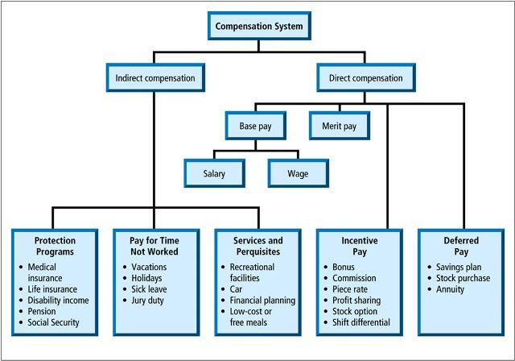
OBJECTIVES -
- To recruit & retain qualified employees.
- To increase or maintain morale.
- To determine basic wage & salary.
- To reward for job performance.
Components of Compensation: -
- Basic pay- the primary part of the pay package is basic pay.
- Allowances-are paid in addition to basic pay
- Dearness Allowances-Dearness allowance also known as cost of living adjustments was used for the first time after World War I to enable the workers to meet the steep rise in prices of essential commodities such as food stuffs.
- House rent allowances-the allowance is calculated as a percentage of basic pay (30%).
- City Compensatory Allowances
- Conveyance Allowances- travelling charges
- Incentives- is performance linked remuneration eg bonus, profit sharing, commission on sale etc,
- Fringe benefits-like PF, pensions, gratuity, encashment of earned leaves, leave travel concession (LTC).
WAGE AND SALARY ADMINISTRATION
“A wage may be defined as the sum of money paid under contract by an employer to worker for services rendered.” -Benham
“Wages is the payment to labour for its assistance to production.” -A.H. Hansen
‘Wage rate is the price paid for the use of labour.” -Mc Connell
Objectives of Wage and salary Administration: -
- To attract qualified and competent personnel.
- To retain the present employees.
- To ensure good performance, loyalty, acceptance of new responsibilities and changes only through good rewards.
- To secure internal and external equity.
- To regulate labour and administrative costs.
- To fix the pay as per the merit of the employees and performance of the job.
- To establish fair and equitable structure of remuneration.

Factors influencing the wage system-
1. Demand and Supply of Labour:
Demand and supply is one of the important factors which influence the wage rates. If the number of workers required is more than availability of workers, then employees will be paid higher rate of work and vice versa.
2. Legal Provisions:
The government had made wage legislations for regular payment and fixation of minimum wages to the workers such as Payment of wages act,1936and minimum wages act 1948. According to this act, payment to be made in time without unauthorised deductions and the employer must pay minimum wages to the worker who is employed in scheduled employment. If any employers do not follow the provisions of these acts, an appropriate action can be taken against him by the authority concerned.

3. Nature of Job:
Wages also depends upon the worker’s skill and the conditions of work. The work conditions can be safe or hazardous. So wages can be high or low, depending upon the worker’s skill and conditions of work.
4. Working Hours:
Wages has a direct correlation with the hours of work per day and overtime wages according to overtime wage.
5. Comparative Wage Levels:
Wage rates also depend upon the wages paid in competitive firms for the same type of work. Wages are therefore fixed after conducting wage surveys.

7. Cost of Living:
Cost of living also determines the wage rates. Wages should be such which satisfies the minimum needs of workers.
8. Type of Employment:
Wages depends upon the type of employment i.e. regular employment or contractual employment. A regular and permanent job provides security of service.

Methods of Wage Payment

Types of wages
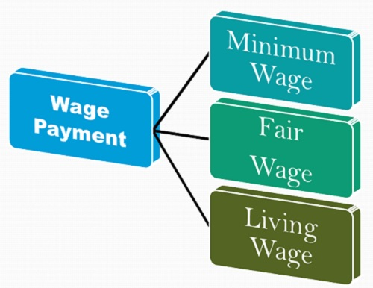

- Minimum Wage Method: Under this method, the minimum amount of wage is paid to the employee irrespective of the employer’s paying ability. It is based on the concept that the wage is paid not for the bare sustenance of life, but for the preservation of the efficiency of the worker.
Thus, the minimum wage must provide for education, medical requirements, and other essential amenities.
- Fair Wage Method: The wage is said to be a fair wage when its amount is similar to the rate that prevails in the same industry in the neighborhood or the rate that prevails throughout the country for the same kind of work.
A standard rate is maintained for the wage that prevails in the other similar industries, and this rate is determined by the companies where exists a unionized labor and is in large numbers.
- Living Wage Method: The living wage is slightly higher than the fair wage, in which the worker not only fulfill his basic needs of life viz. food, clothing and shelter, but also avail the frugal comforts such as education of children, insurance, protection against ill health, essential social needs, etc.
The rate of the living wage is determined on the basis of economic condition prevailing in the country. Therefore, these wage rates may differ from country to country.
Thus, the employers follow different methods of wage payment depending on their paying capacity and the economic conditions prevailing in the country

GRIEVANCE REDRESSAL
A grievance is any dissatisfaction or feeling of injustice having connection with one’s employment situation which is brought to the attention of management. Speaking broadly, a grievance is any dissatisfaction that adversely affects organizational relations and productivity.

Features of Grievance:
1. A grievance refers to any form of discontent or dissatisfaction with any aspect of the organization.
2. The dissatisfaction must arise out of employment and not due to personal or family problems.
3. The dissatisfaction may be valid and legitimate or irrational and ridiculous or false.
4. Grievances if not redressed in time tend to lower morale and productivity of employees.

Causes of Grievances

Effects of Grievance:
Grievances, if not identified and redressed, may adversely affect workers, managers, and the organization.
1. on the production:
a. Low quality of production
b. Low productivity
c. Increase in the wastage of material, spoilage/leakage of machinery
d. Increase in the cost of production per unit

2. on the employees:
a. Increase in the rate of absenteeism and turnover
b. Reduction in the level of commitment, sincerity and punctuality
c. Increase in the incidence of accidents
d. Reduction in the level of employee morale.
3. on the managers:
a. Strained superior-subordinate relations.
b. Increase in the degree of supervision and control.
c. Increase in indiscipline cases
d. Increase in unrest and thereby machinery to maintain industrial peace.
Understanding Employee Grievances

- Exit interview
- Opinion Surveys
- Gripe Boxes
- Open Door policy

Grievance Procedure
There are two procedures for redressing the grievances of the employees:
1) Open door policy: Under this procedure the employees are free to meet the top executive of the organisation and get grievances redressed.
2) Step-ladder procedure: Under this procedure, the aggrieved employee has to proceed step by step in getting his grievance heard and redressed.

Step-ladder procedure:
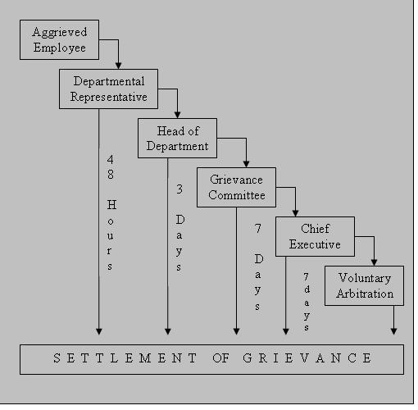

The procedure consists of the following stages:

Stage 1:
The worker fills in a grievance form and submits the same to the shift in- charge for information and consideration.

Stage 2:
In case, he is not satisfied with the decision, he goes to the departmental head for the settlement of his grievance.

Stage 3:
If the aggrieved employee is still dissatisfied, he forwards it to the appropriate chairman of the zonal works committee (ZWC). Each zonal works committee consists of five management and five union representatives. Their decision is final and binding on both the parties. The individual grievances considered by the zonal committee pertain to promotion, suspension, discharge and dismissal.

Stage 4:
If the zonal committee either does not reach to a unanimous decision or the decision is not accepted by the employee, the grievance is, then, forwarded to the central works committee. This committee consists of representatives of top management and union officials. Here also, the unanimity of principle operators and the decision taken by the committee is binding on both the parties.

Stage 5:
If this committee also does not reach to a unanimous decision, the matter is referred to the Chairman of the company. His or her decision is final and is binding on both the parties.
The stage at which the grievance is settled indicates the climate or the spirit that prevails in the organisation. Obviously, lower the level of settlement, the quicker the redressal of a grievance.

DISCIPLINE
Discipline means orderliness or the absence of disorder, chaos and confusion in human behaviour and action. In other words, discipline implies behaving in a desired manner. By that we mean that employees confirm to the rules and regulations framed by the organisation for an acceptable behaviour. Following definitions of discipline will make its meaning more clear.
According to Richard D. Calhoon’, “Discipline may be considered as a force that prompts individuals or groups to observe the rules, regulations and procedures which are deemed to be necessary for the effective functioning of an organisation”.
Causes of indiscipline:-
- Ineffective leadership
- Lack of a well-defined code of conduct to guide behaviour on both sides.
- Faulty supervision
- Divide and rule policy of management.
- Defective communication skills
- Victimisation and excessive work measures.
- Political and trade union influences.
- Low wages and poor working conditions.
- Undesirable behaviour of senior officials.
- Faulty evaluations of persons and situations by executives.
- Improper co-ordination, delegation of authority and fixing of responsibility.
- Inborn tendencies to flout rules.

TYPES OF DISCIPLINE

Essentials of a Good Disciplinary System
- Knowledge of rules-
- Code of discipline (published in employee handbook).
- Prompt Action-
- Punishment or penalty should not be delayed.
- Fair Action-
- The disciplinary system should be based on the principles of natural
justice.
- Employees should be given time for explanation.
- Well -Defined procedure-
- Definite and precise provisions for appeal and review of all disciplinary action should be communicated.
- Action should be taken in private.
- Constructive Approach-
- Disciplinary action should be preventive rather than punitive.
- Self -discipline is the best form of discipline and management should encourage this.
- Review and Revision –
- All rules and regulations should be appraised at regular intervals.
RED HOT-STOVE RULE-
Douglas McGregor has suggested this rule to guide managers in enforcing discipline. The rule is based on an analogy between touching a red - hot stove and violating rules of discipline. When a person touches a hot stove,
- The burn is immediate.
- He had warning as he knew that he would get burn if he touched it.
- The effect is consistent.
- The effect is impersonal.
- The effect is commensurate with the gravity of misconduct.

Approaches to Discipline

Judicial Approach
Under this approach, the nature of offence in a particular situation is determined by carefully weighing the evidence and taking all the steps prescribed for disciplinary procedure.
Human Relations Approach
Under this approach the offender is treated as a human being. If he has violated the rules, the human relations approach would ask the question, why did he violate the rule? For example, sleeping during the night-shift might be due to the fatigue caused by factors over which the man has no control, e.g. illness in the family.
In such a case, an attempt should be made to help the worker to get over such a personal difficulty or to change the shift of duty or to shift him to a job which he can conveniently handle rather than take an extreme view and punish him severely.
Human Resources Approach
Under this approach every employee is looked upon as a resource to the employer and that the human resource is the most important factor of production. This resource has to be trained, motivated and brought up to the level of efficiency required by the organisation.
Group Discipline Approach
If the organisation has well-established norms of conduct, it should try to involve groups of employees in the process of discipline.
The group as a whole can control an individual worker who is its member much more effectively than the management can through penalties.

Leadership Approach
Every manager has to develop a leadership quality as he has to guide, control, train, develop and lead a group of men and act as a leader whatever may be his position in the organisational hierarchy.
Disciplinary Procedure
- Issuing a letter of charge to the employee calling upon him for
explanation
- Consideration of the explanation
- Show- cause notice
- Holding of a full-fledged enquiry
- Considering the enquiry proceedings and findings and making final order
of punishment
- Follow-up.
Types of punishment
- Oral warnings
- Written warnings
- Loss of privileges and fines
- Punitive Suspension
- Withholding of increments
- Demotion
- Termination.

Grievance Redressal in Indian Industry
- The Industrial Employment (Standing orders) Act, 1946-
- Establishment employing 100 or more worker should make provision for
means of redressing the workers against unfair treatment or wrongful
exactions by the employer.

- The Factories Act, 1948-
- Appointment of welfare officers in every factory wherein 500 or more
workers are employed.
- Main task of welfare officer is to deal with grievance and complaints.

- The Industrial Disputes Act, 1947-
- Establishment were 50 or more workmen are employed shall have
Grievance Settlement Authority for settlement of Industrial Dispute.

WORKER/LABOUR PARTICIPATION IN MANAGEMENT

According to Keith Davis, “Workers’ participation refers to the mental and emotional involvement of a person in a group situation which encourages him to contribute to group goals and share in responsibility of achieving them”.
Objectives of WPM in India are to:
1. Promote mutual understanding between management and workers, i.e., industrial harmony.
2. Establish and encourage good communication system at all levels.
3. Create and promote a sense of belongingness among workers.
4. Help handle resistance to change.
5. Induce a sense among workers to contribute their best for the cause of organisation.
6. Create a sense of commitment to decisions to which they were a party.
7. To build the most dynamic human resource.
8. To strengthen labour management co-operation and thus maintaining industrial peace.
9. To satisfy the workers social and esteem needs.
10. To promote increased productivity for the advantage of the organisation, workers and society at large.

Forms of Worker’s Participation in Management

Works Committee:
Under section 3 of the Industrial Disputes Act, I947, and the appropriate Government may require an enterprise employing 100 or more workers, to constitute a works committee with equal number of representatives from the employees and the management. The main purpose behind Constituting works committees is to evolve ways and means for maintaining cordial and harmonious relations between the employees and the management.
Functions:-
- Discussion on condition of work for eg. Lighting, ventilation,
temperature, sanitation etc.
- Recreational and educational activities and encouragement of thrift and
savings.
- To promote for securing and preserving amity and good relations between
employers and employee.

Structure:-
- President- nominee of the employer
- Vice president –workers representative
- Other – secretary, joint secretary and office bearers.
- Tenure of the body is for 2years.
- Total strength of these bodies should not exceed 20.

Organisation using this is –
- HUL
- Tata iron and steel company
- Indian Aluminium Works at Belur.

- Joint management Councils (JMc’s)-
- JMCs were introduced first in 1958. These councils are formed at plant level with equal number of representatives from employers and employees. These are mainly consultative and advisory ones. Hence, neither the workers nor the employers take them seriously.
- A sub-committee consisting of representatives of employers, workers and government should set up for considering the details of workers participation in management schemes.
Objectives:-
- To increase the association of employers and employee thereby promoting cordial industrial relations.
- To improve the operational efficiency of the workers.
- To provide the welfare facilities to them.
- To satisfy the psychological needs of workers.
A tripartite sub- committee was set up as per the recommendations of Indian labour Conference which laid down certain criteria for selection of enterprise where the JMCs could be introduced. They are-
- The unit must have 500 employees or more
- Fair record of IR
- Well organised trade union
- The management and the workers should agree to establish JMCs.
- Trade union should be affiliated to one of the Central Federation.

Functions-
- To be consulted on, matters like standing orders, retrenchment, rationalisation, closure, reduction of operations etc.
- To receive information, to discuss and offer suggestions.
- To shoulder administrative responsibilities like maintaining welfare measures, safety measure, training schemes, working hours, payment of rewards.

- Joint Councils-
In every industrial unit employing 500 or more employees there was to be a joint council for the whole unit.

Features are:-
- Joint council shall function for 2 years.
- Only such members who are actually engaged in the unit shall be member
of the joint council.
- Chief executive of the unit will be the Chairman of the joint council and
vice-chairman will be nominated by the workers-members of the council.
- One member as secretary should be appointed and he is responsible for
discharging the functions of council.
- The joint council should meet at least once in a quarter.
- Every decision of the joint council shall be on the basis of consensus and
not by process of voting and shall be binding on employers and workmen
and shall be implemented within one month.
Functions –
- Preparing schedules of working hours and of holidays.
- Developing skills of workmen and adequate facilities for training.
- Rewards for valuable and creative suggestions received from workers.
- General health, welfare and safety measures for the plant or the unit.
- Optimum use of raw material and quality of finished products.

- Shop Councils-
- Government of India on the 30th of October 1975 announced a new scheme in WPM. In every Industrial establishment employing 500 or more workmen, the employer shall constitute a shop council. Shop council represents each department or a shop in a unit. Each shop council consists of an equal number of representatives from both employer and employees. The employers’ representatives will be nominated by the management and must consist of persons within the establishment. The workers’ representatives will be from among the workers of the department or shop concerned. The total number of employees may not exceed 12.
- The decisions of the shop council are to be taken on the basis of consensus but not by voting.
- Tenure of shop council is of 2 years. Members of shop councils should meet at least once in a month.
- The number of the shop council to be established in an organization is determined by the employer in consultation with the recognized trade union/workers of the organization. The decision of a shop council which has a bearing on another shop will be referred to joint council for consideration and approval.

Functions of Shop Councils:
  - Assist management in achieving monthly production targets.
  - Improve production and efficiency, including elimination of wastage
of man power.
  - Study absenteeism in the shop or department and recommend steps to
reduce it.
  - Suggest health, safety and welfare measures to be adopted for smooth
functioning of staff.
  - Look after physical conditions of working such as lighting, ventilation,
noise and dust.
  - Ensure proper flow of adequate two way communication between
management and workers.

- Unit Councils-
- Settings of unit council in units employing any least 100 persons.
- The organisation includes hotels, restaurants, hospitals, air, sea, railways
and road transport services, ports and docks, ration shops, provident fund
and pension organisation, municipal and milk distribution services, food
corporation, state electricity boards , training organisation of the Central
and State Governments.
- The schemes provides for unit level councils.

Main features of the Schemes-
- Organisation employing 100 or more employees to discuss day to day
problems and find solutions.
- The management’s representatives should be nominated by the management
and should consist of person from unit person.
- All decision of the unit council shall be on the basis of consensus and not by
voting.
- Unit council formed shall function for a period of 2 years.
- The council shall meet as at least once in a month.
- The Chairman of the council shall be a nominee of the management. The
worker members of the council shall elect a Vice- chairman from amongst
themselves.

Functions-
- To create condition for optimum efficiency and better customer services.
- To identify area of chronically bad, inadequate or inferior service.
- To study absenteeism and recommend step to reduce it.
- To eliminate pilferage and all form of corruptions. And create a system of
reward for this purpose,
- To suggest improvement in working condition and facilities.
- To ensure proper channel of communication between management and
workers, especially in the areas of services to be rendered, fixation of target
and process of achieving this target.
- To recommend and improve provision relating to safety, health and welfare for
smooth running of the unit.

Suggestions for the Success of Worker’s Participation in Management
                - In the process of WPM, parties involve must have mutual trust, faith among
themselves.
                - Management must be progressive and should recognise its obligation and
responsibilities towards workers and trade union.
                - The trade union should be strong, democratic and representative which should
represent the cause of the workers without neglecting the management interest.
                - Both the parties of WPM must have the common objective-closely and
mutually formulated.
                - All parties involved in WPM must have the feeling that they can participate in
all levels.
                - There should be effective communication between workers and management.
                - Parties involved in negotiation should develop a favourable attitude towards
the solution of the problem.
                - For the effective participation it is the duty of the management and government
to provide effective training to all concern involved in participation
management.
                - To conclude both the parties of anticipative management should be aware of
the fruits of the schemes.

