RENAISSANCE LAW COLLEGE
B.COM LLB SEM II

BUSINESS COMMUNICATION

UNIT I

BUSINESS COMMUNICATION

- Meaning
- Ingredients
- features of communication
- role and importance of communication in business
- Progress of communication.

Business Communication

- The word “Communication” has come from the Latin word “communis”, which means common. Thus, communication signifies sharing of ideas in common.

- According to W. H. Newman and C. F. Summer, “Communication is an exchange of facts, ideas, opinions or emotions by two or more persons.”

- “Communication in its simplest form is conveying of information from one person to another.” Hudson
- “Communication is the process of passing information and understanding from one person to another.” Keith Davis

- Communication is the process of transmitting information and understanding from one person to another or from one unit to other unit with a view to getting the desired response from the receiver. Through this process two or more persons exchange ideas and understanding among themselves to achieve the desired effect in the behaviour of another person.
- It is a two-way channel for transmitting ideas, feelings, plans, commands, instructions, reports and suggestions that influence the attitude towards an organisation’s objectives. The communicator’s goal is to convey the meanings or ideas without distortion. Success of the leader and the enterprise depends upon adequacy of communication.
- It is essential for success and growth of an organization.Communication gaps should not occur in any organization.

According to Harold D. Lass well, a convenient way to describe an act of communication is to answer the following questions:
- Who
- Says What
- In Which Channel
- To Whom
- With What Effect?

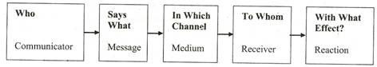

Elements of Business Communication:

- Two or more parties: Business communication must involve at least two parties. One party acts as the sender of message and another is the receiver of that message.
- Meaningful message: The second important elements of communication are message or information that the sender wants to communicate. Messages may take the form of feelings, wishes, attitudes, ideas, facts, information or any other perceivable matter. The messages that a sender wants to send, should be meaningful to the receiver.
- Business related information/sender: Information that the sender transmits should be related to business. Similarly the feedback from the receiver should also be business based.
- Media or channel: Channel of medium is a pre-requisite of communication. It is the means of transmitting messages from sender to receiver. Communication media can be verbal and nonverbal. The verbal media may be of oral and written. Verbal media of communication include telephonic conversation, fax, newspaper, books, journals etc. On the other hand, gestures, and body language, facial expression etc. Are the media of non-verbal communication. The sender must select appropriate media for successful communication.
- Feedback: The final element of communication is feedback. It is the response or reaction of the receiver regarding the sender’s message. Feedback describes how the message is being interpreted by the receiver. It is regarded as the instrument for evaluating the success of communication process.

Process of Business Communication:
The process or steps of communication involves a series of actions and operations undertaken for the fulfillment of a certain end or objective.
According to Lawrence A. Appley, the basic communication process involves the following steps:
(i) Clarifying the idea or problem,
(ii) Getting participation in developing a solution to the problem,
(iii) Transmitting the idea or decision,
(iv) Motivating others to take action agreed upon, and
(v) Measuring the effectiveness of communication.

Steps of business communication can be described as follows:

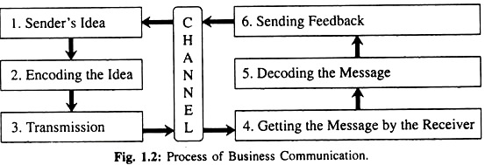

1. Sender’s Idea:
The first thing in communication process is to be familiar with the idea or problem to be communicated. If the communicator has no clear view of this idea or problem, its reception on the other end may give similar obscure idea and may thus be misunderstood. So, the process of communication demands full and clear view of the idea or problem to be communicated.

2. Encoding the Idea:
When the idea is converted into a symbolic form in terms of some kind of language, it may be termed as the encoding of the idea. The language may consist of words, symbols, charts, diagrams, gestures, etc. This encoding depends upon the personal characteristics of the sender as well as the receiver. The style, length, form, clarity, etc. of the message varies from person to person.

3. Transmission:
In transmitting the ideas or decisions, certain matters are to be taken into consideration. The first consideration should be to select an appropriate channel (i.e., verbal, non-verbal, written, etc.) and a medium (telephone, e-mail, letter, face to face conversation, etc.).
This selection depends upon urgency, distance, availability of means, cost and time factor, etc. Next thing is to determine the person or persons to whom such ideas or decisions are to be communicated. So, the selection of right course and right person for communication is essential for its effectiveness.

4. Getting the Message by the Receiver:
The receiver must get the message to make the communication fruitful. Suppose a letter or e-mail is sent to a person. It is not possible for him/her to go through it and understand its meaning unless it is received by him/her.

5. Decoding the Message:
Decoding means understanding or bringing out the meaning of the message. It is very vital. If the receiver understands the message in the same sense as the sender intends, the objective of communication is presumed to be fulfilled.

6. Sending Feedback:
Feedback is the receiver’s response to the message. Having understood the message the receiver reacts to it and responds accordingly. The feedback evaluates the effectiveness of the message. If the sense of the message is realist properly, the feedback or the response will be desirable and, if it is not, one has to understand that there are some barriers in the process. Steps are required to be taken for the removal of such barriers.

7. Channel:
Channels are the routes or paths of the communication. The sender’s idea is transmitted to the receiver through this path. Again, the receiver sends feedback to the sender through the channel. Thus, channel is used at least twice in the process of communication. Oral or telephonic message, letter, different audio and video media, computer, e-mail, fax, etc. are the popular channels of communication. Selection of channel depends upon the nature of the message, necessity, urgency and situational conditions.

8. Noise:
It is not a separate step in the process. It may be present at every step and make the communication less effective or ineffective. Noise distorts the message and conveys ideas not intended by the sender resulting in chaos, confusion and complexity.

Features of Business Communication

To communicate effectively in the business world is not an easy job. A good communicator should
(i) Interchange of information:
The basic characteristic of human communication is that it aims at exchanging information. It is a two-way process. The exchange can be between two or more persons. It may be at the individual or the organizational level.
(ii) Continuous process:
Communication is a continuous process. It is not static. It is constantly subject to change and is dynamic. The people with whom communication is held, its content and nature, and the situation in which communication is held – all keep changing.
(iii) Mutual understanding:
The main purpose of communication is to bring about mutual understanding. The receiver should receive and understand the message in the manner that the sender intended him to.
(iv) Response or reaction:
Communication always leads to some response or reaction. A message becomes communication only when the receiving party understands and acknowledges it, and also reacts and responds to it.
(v) Universal function:
Communication is a universal function, which covers all levels of auth (vi) Social activity:
Communication is a social activity, too. The components of a society are into a relationship of sharing, be it information, feelings or emotions.
The same holds true for business communication. It involves the effort of people to get in touch with one another and to make them understood.

Importance or role of business communication

- Exchanging information
- Preparing plans and policies
- Execution of plans and plaices
- Increasing employee’s efficiency
- Achieving goals
- Solving problems:
- Making decisions
- Improving industrial relation
- Enhancing employee satisfaction
- Enhancing loyalty

Importance of Communication for Managers

- To achieve the objectives.
- To organize
- To encourage and communicate.
- To measure the work.
- To develop personality.

UNIT II
- Dimension
- Channel and media of communication
- Downward ,upward, literal and diagonal communication
- Formal and informal channel of communication and its merit & demerits
- Media of communication: verbal &non-verbal communication.

Dimension

Every business organization is concerned with two type of communication
Upward Comm.
Horizontal Comm.
Horizontal comm.
Downward Comm.
Internal communication

Internal Communication
- It Means communication within the organization.
External communication
- Communication with other business units, banks, government offices, press, customers &general public.

Intercorporate
Shareholder
Companies

External Communication
Dealer
Public
Government

Fig: External Communication

Internal Communication-
- It is the communication that relates directly to the foundation of an organisation- the people, staff, management and volunteers- that give your organisation its ability to function.

Dimension & Direction of Communication
Downward
Probability
Gossip
Single Stand
Grapevine
Upward
Diagonal
Horizontal/lateral
Vertical
INFORMAL
FORMAL

Cluster
- Formal Communication
- It is an official network prepared by management.
- Formal communication refers to interchange of information officially.
- The flow of communication is controlled and is a deliberate effort. This makes it possible for the information to reach the desired place without any hindrance, at a little cost and in a proper way.

Board of Director Level A

Managing Director Level B

Departmental Manager Level C

Supervisors Level D

Clerks & Operatives Level E

Advantages of Formal Communication

1. Being official, formal communication is binding and effective;
2. Formal communication is generally written. So, there is less possibility of any ambiguity or misunderstanding.
3. Being written, it can be preserved and used as reference in future;
4. The responsibility of the sender and the receiver is great as formal communication is official;
5. Formal communication is less time-consuming as compared to informal communication which consumes lots of time in discussion, side-talks and even arguments;
6. It helps to maintain an overall control on the employees as it emerges from authority-subordinate relationship.

Disadvantages of Formal Communication:
- It increases the workload of various managers through whom the message is transmitted.
- In case the communication is made between high-official as his subordinates then it has an adverse effect on their relations.
- If transmitted message gets changed by the middle level officials or workers then its authencity or reliability is reduced.
- This communication leads to red-tapism.

- Vertical Communication:
- It takes place between management and its subordinates.
- Its direction is from management to subordinates or vice a versa.

Upward Downward Communication Communication

- Downward Communication
- Its direction is from high to low.
- Such communication in general contains the directives and messages to workers regarding their functioning.

- Directive letters
- Pamphlets
- Policy statements
- Manuals
- Circulars
Oral
- Instructions
- Orders
- Speech
- Meetings
- Telephone
- Loudspeakers.
Written
Downward Communication

2.Upward Communication
This is quite the reverse of the downward communication. This flows from the subordinates to the superiors. The subject-matter of this communication includes suggestions, reactions, reports, complaints, etc. This sort of communication helps the superiors in taking decisions.

METHODS OF UPWARD COMMUNICATION
- PERIODIC MEETINGS
- OPEN DOOR POLICY
- SUGGESTION BOX
- INFORMAL MEETS
- COUNSELLING

- Horizontal or Lateral communication
- It creates the feeling of cooperation and collective work.
- This communication takes place among officers or employees of equal level.
- It develops the feeling of mutual understanding
OBJECTVES:-

- It creates cooperation among various departments and among employees of an organization.
- To resolve the problems with the help of experts or specialists.
- To exchange information or messages among the employees of different departments of an organization.
- To develop social relations among employees of the organization.
- To resolve the conflict among officers or employees.

Advantages of horizontal communication
- Informal relationship
- Co-ordination of activities
- Departmental communication
- Hindering bureaucracy
- Quick communication and solution of problems.
- Linking with different areas of expertise
- Guarding against distortion message

Drawbacks of Horizontal Communication

- Increased specialization
- Lack of recognition and reward
- Suppression of Differences
- Ego clashes
- Low productivity
- Ignoring vertical communication
- Overloaded by information

Personnel & administration

Finance & Accounts
Production
Marketing

Fig: Horizontal or lateral communication between various departments of an organization.

- Diagonal Communication/Crosswise Communication

- It includes communication between employees on the different levels who have no direct communication relationship.
- The concept of diagonal communication was introduced to capture the new communication challenges associated with new organizational forms, such as matrix and project-based organizations.
- For eg: To design a training module a training manager interacts with operation personnel to inquire about the way they perform their task.
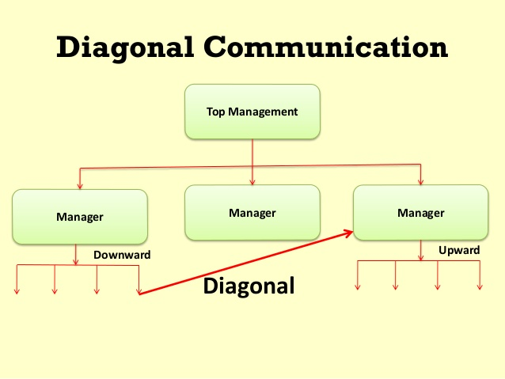

Advantages
- Building of cross department teams
- Selecting the right person for transmitting the information
- Fast method of communication
- Encourages friendliness & informality
- Correct information is transmitted
- Effective in critical situations.

DISADVANTAGES OF DIAGONAL COMMUNICATION / CROSS WISE COMMUNICATION

- Destroys lines of authority
- Creates ego issues
- Lead to conflicting orders & hence further confusion
- Verbal & hence no accountability

- Informal Communication

- The Informal Communication is the casual and unofficial form of communication wherein the information is exchanged spontaneously between two or more persons without conforming the prescribed official rules, processes, system, formalities and chain of command.
- The informal communications are based on the personal or informal relations such as friends, peers, family, club members, etc. and thus is free from the organizational conventional rules.
- The informal communication is characterized by an indefinite channel of communication, which means there is no definite chain of command through which the information flows.
- Informal communication is also called grapevine communication because there is no definite channel of communication.
- There are four types of Informal Communication (Grapevine) network that show how the communication is facilitated. These are:
- Single Strand Chain
- Gossip Chain
- Probability Chain
- Cluster Chain
- Single Strand Chain Information is passed on in chains.

- Gossip Chain Information is conveyed to all persons
simultaneously without particular
person.

- Probability Each person randomly conveys
Information to another person.

- Cluster A person conveys information to few
persons, out of them again few
persons pass it on to next few.

Advantages of Informal Communication

- Fast and Effective Communication
- Free Environment
- Better Human Relations
- Easy Solution of the Difficult Problems
- Satisfying the Social Needs of the Workers
Limitations

- Unsystematic Communication
- Unreliable Information
- Maintaining secrecy is impossible
- Difficulty in controlling
- Non-cooperation

CHANNEL OF COMMUNICATION

- Channel refers to that path through
which information passes or flows from one
person to another.
- Channel refers to the means of
transmission of a message between the
sender and the receiver.
- Channel could be a letter, a report, a book, a
memorandum, a fax, an email, the television, the telephone, etc.

CHANNEL

- Refers to the factor that is used to convey the information. A medium serves as the means of communication.
- A medium, which is an abstraction, can beoral, written or nonverbal.

MEDIUM

A sender conveys his/her message to the receiver by some medium (oral, written or non verbal) over some channel (electronic means or printed Media).

CHANNEL OF COMMUNICATION
Downward
Lateral/Horizontal
Upward
Diagonal
Vertical
Informal
Formal
Written
Gestures
Oral
On the basis of Organisational relations
On the basis of Expression
On the Basis of Flow

In today’s scientific age number of media is available for communicating messages and information: but on the basis of language it may be classified in two groups:

Medium Of Communication

Non-verbal
Verbal

Body Language
Sign -Language

Audio Sign
Visual Sign

I. Verbal Communication: -
- It is through a language, which basically acts as a medium to convey the idea, thought or feeling of a sender to the receiver or listener.
- The word verbal comes from the Latin word for word – verbum. Meanwhile, the word communication comes from the Latin word for to share – communicare. So, it follows from this that verbal communication means sharing things by means of words.
- Verbal communication can be taken to mean many different things. However, one thing is always clear: words must always be involved in verbal communication. Words have been used for centuries as carriers of meaning

- Verbal communication is of two types:
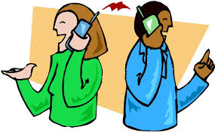

Oral Communication
Written Communication

1. Oral Communication-
- Transmission of orders, messages, information or suggestions through spoken words is called ‘Oral or Verbal Communication’.
- It is effective for communication in meetings, conferences, gatherings, group discussions, interviews, face-to-face talks, telephonic talks, etc.

- Candid
- Clear
- Complete
- Concise
- Concrete
- Correct
- Courteous

7-C’s for effective oral communication.

Disadvantages of Oral Communication

- Oral communication is not possible when sender & receiver are far away from each other or no mechanical devices are available to connect them orally.
- It is suitable for small and simple messages.
- It lacks recorded evidence for future.
- It does not allow the listener much time to think, act and react.
- It can be easily distorted or changed.

Advantages of Oral Communication:

- Save time & money
- Better control on subordinates is possible.
- This medium is more effective than other media.
- In this communication gestures,signs,indications,variations in tone pitch & intensity of voice can be seen and felt, which is not possible in other media.
- It strengthens mutual relations.
- Feedback is received instantly in this communication.
- It helps in creating healthy atmosphere in an organization.

2. Written Communication

- A ‘Written Communication’ means the sending of messages, orders or instructions in writing through letters, circulars, manuals, reports, telegrams, office memos, bulletins, etc.
- It is a formal method of communication and is less flexible. A written document preserved properly becomes a permanent record for future reference.

- This communication provides the facility of preparing well-thought draft of message or information before communicatin

Advantages of Written Communication

1. It is suitable for long distance communication and repetitive standing orders.
2. It creates permanent record of evidence. It can be used for future reference.
3. It gives the receiver sufficient time to think, act and react.
4. It can be used as legal document.
5. It can be sent to many persons at a time.
6. It is suitable for sending statistical data, chart, diagram, pictures, etc.
7. Order, allocation of work, job distribution, etc. in written form reduce ambiguity and help in fixation of responsibility.
8. Uniformity in work procedure can be maintained through written communication.

Disadvantages of Written Communication
1. It is time-consuming. Composing a message in writing takes much time. Feedback process also is not instant.
2. It is expensive not so much due to postal charges but in terms of so many people spending so much of their time.
3. Written communication has no scope for immediate clarification if not understood properly.
4. Being written in nature it is less flexible and cannot be changed easily.
5. It is not effective in the case of emergency.
6. It takes much time in removing confusion or doubt.

6.

UNIT III
- Written Communication Skill for business correspondence:
a). personnel –letter calling candidates for written test, drafting of interviews letters, appointment letters.
b). purchase: request for outstations, tenders, test orders, complaints and follow -up

Writing Skill is an important element of written communication. It is necessary for effective writing of letters, memorandum, reports, speeches etc. in the present day business.
A written document becomes a permanent record and others can receive the message through this record from time to time & therefore it is necessary to write such documents skillfully.
Writing Skill has four stages:-

1. Planning
2. First Draft
3. Amendment.
4. Editing

FIRST STAGE:- under planning the following five elements are included:
- Objectives
- Audience analysis
- Selection of thoughts
- Collection of data & facts as per thoughts &
- To make proper sequence of message.

SECOND STAGE: -In this first draft is written. It includes converting thoughts into words and sentences & to frame it in paragraphs as per requirement.
There are two styles of writing first draft:
- Linear (facts are presented in a serial order).
- Circular (presentation of thought is quite elastic).

THIRD STAGE: - In this stage, the first draft is amended as 7 where necessary. All important and necessary information is included and unnecessary information is excluded.

LAST STAGE: - The last stage of writing skill is of editing the draft by improving sentence formation and correcting grammatical errors. The message is given an effective form.

Guidelines for Effective Writing
1. The following questions have to be answered for effective writing:
- Why to write?
- For whom to write?
- What to write?
- Where to write?
- When to write?
- How to write?
2. Short and simple words should be used.
3. It should always be brief.
4. It should be appropriate /according to subject.
5. It should be factual 7 trustworthy.
6. Strong words should be used.
7. Avoid unnecessary and unwanted words and sentences.
8. Keep the paragraph small.

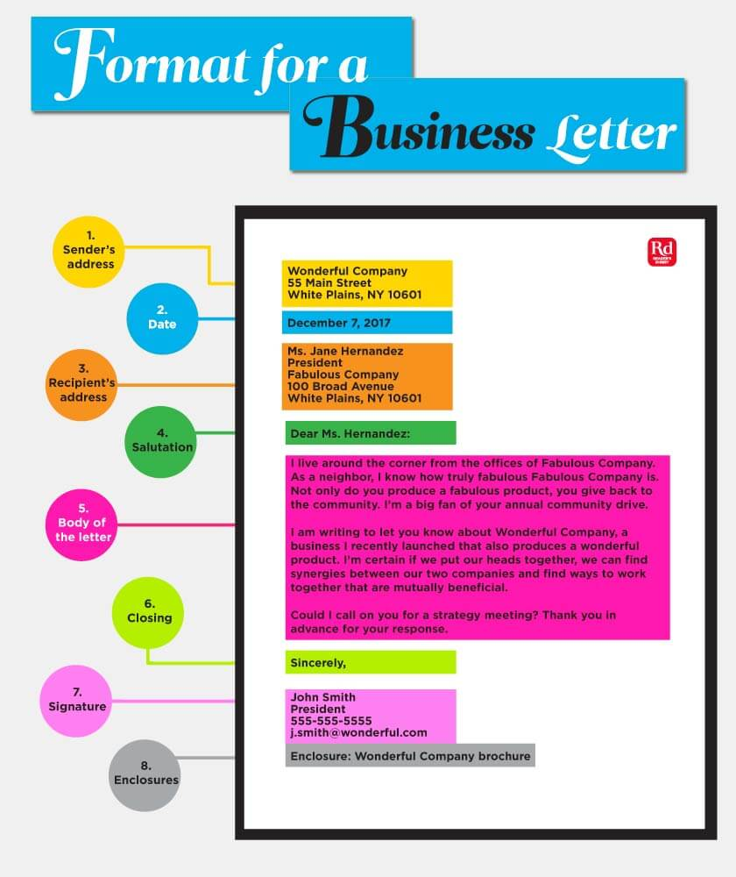

Parts of Business Letter

1. Heading- The following points are included in “heading” :
- Name of the firm
- Nature of business
- Address
- Telephone number
- Mobile number
- E-Mail address
- Code.
2. Date
- Date must be given on each letter in full i.e date, month and year.
- It is generally given on the right side below the name of the city /town.
Example-
- July 14,2019 (American Style)
- 14 July, 2019 (Oxford style).

- Name & Address of the recipient or inside Address.

- Full and correct address is very necessary so that identity of the recipient can be established.
- It includes the name, address, postal code, and job title of the recipient. It must be mentioned after the reference. One must write inside address on the left-hand side of the sheet.
Individual
Business Letter
Addressed to

Firm

Limited Co.

Society

Govt. Deptt.

Salutation
- The standard salutation for a business letter is the salutation Dear, followed by the person’s name and sometimes a title, closing with a colon.
- Dear Ms. Reader:
Dear Janet:
Dear Attorney Adams:
- The standard salutation for a more social business letter, or personal letter is the salutation Dear, followed by the person’s name and sometimes a title, closing with a comma.
- Dear Ms. Writer,
Dear Andrew,
Dear Pastor Amanci,
- Sir and Madam is very formal and therefore used when letters are written to government departments.
All of these salutations begin with the word “dear.” While you can simply start a letter with the person’s name, that can be misinterpreted as abrupt or even rude. It's always safe to begin your salutation with the word “dear” in a business letter.

General Salutations for Business Letters
- Dear Hiring Manager
- To Whom It May Concern
- Dear Human Resources Manager
- Dear Sir or Madam

- Subject Heading
- Some firms after salutation give the subject- heading also in the centre.
- It is a brief statement mentioning the reason for writing the letter. It should be clear, eye catchy, short, simple, and easily understandable.
- For example:

Dear Sir,
Subject: Enquiry for Maruti Car

- Body of the Letter
This is the main part of the letter. It contains the actual message of the sender. The main body of the mail must be clear and simple to understand. A body of the letter is basically divided into three main categories.
- Opening Part: The first paragraph of the mail writing must state the introduction of the writer. It also contains the previous correspondence if any.
- Main Part:
- This paragraph states the main idea or the reason for writing.
- This contains the real message to be conveyed to the recipient of information.
- It must be clear, concise, complete, and to the point.
- Separate paragraph for each point is more effective.
- Concluding Part: It is the conclusion of the business letter. It shows the suggestions or the need of the action. The closing of the letter shows the expectation of the sender from the recipient. Always end your mail by courteous words like thanking you, warm regards, look forward to hearing from your side etc.

- Complementary Close
- To close the letter, insert a phrase such as “sincerely” or “Thank you” or “Yours faithfully” or “Best regards”, “followed by a comma. The most common closing is “Sincerely. “Insert four lines between the closing and sender’s name. This space will be used for your signature once the letter is printed. Sign the name in the space above your name.
- There re various complementary phrases but complementary phrase befitting to salutation should be chosen.

S.No. | Salutation used | Complementary close
 | Dear Sir | Yours faithfully
 | Dear Mr. | Yours truly
3. | My Dear Mr. | Yours very truly

Yours sincerely personal letters.

Yours obediently/ yours respectfully subordinate writing letters to
superior in Govt. Deppt

- Signature
- Signature is put up just below the complementary phrases, a bit right hand side in such a way that it ends near the margin.
- The letter is supposed to be complete and final after signature.
- Signature is very important as it carries with it all responsibility of the letter.
- Designation
- Below signature, name & designation of the person signing & name of the organization is written.

- Enclosure
- Enclosures show the documents attached to the letter. The documents can be anything like cheque, draft, bills, receipts, invoices etc. It is listed one by one.

11. PostScript
- The sender can mention it when he wants to add something other than the message in the body of the letter. It is written as P.S.

Personnel –letter calling candidates for written test

1.Name of the applicant; register number or serial number of application, job name and its code number.

2. Date and time of examination with duration is mentioned.

Example: test will be conducted on 15th May 2019 from 10a.m. to 12 noon.

3. Details of the examination center , name of the town and address of the venue are given in detail to make it convenient and easy for the applicant to attend without trouble.
Example: Convocation hall Andhra University.

4. Time to report to the supervisor at examination hall, time to allow candidate to write examination including grace time to time of completion is given in detail to facilitate the candidates to make necessary arrangements to reach the venue.

Example: Examination commences at 10am and duration is 2hrs. Candidates are expected to report at the venue in their respective rooms before half an hour to check their hall ticket numbers. Candidates are permitted to the examination hall till 10;30 am and are not allowed to leave the hall till the expiry of the time i.e only at 12 noon.

5. Detail of nature of examination are given with a modal paper and syllabus. Number of papers to be answered is also given in detail.
6. Instructions with regard to arrangements they have to make at examination.
Example: only HB pencil is allowed.

7. Clarifications are also given: no TA and DA are paid or no travelling expenses are paid. No accommodation is provided. Candidates have to bear all expenses.

CALL LETTER FOR INTERVIEW

With reference to your application, we are pleased to call you for a personal round of Interview at our office in Navi Mumbai.

Interview details –

- Days : Monday to Friday(except national holidays)
- 10.00 AM : Company Over view
- 11.00 AM : Written Examination
- 12.30 PM : Lunch
- 01.00 PM : Laboratory Tour
- 02.00 PM : Interview
- 03.00 PM : Interview Results
- 03.30 PM : Joining Formalities

Documents to be carried -

- Attested copies of o Educational Qualifications.
- Residential address proof (Passport/Voters ID/ Ration Card/ Driving License).
- Relieving letter – if experienced
- Latest Salary slip – if experienced
- 3 Passport size photographs and 2 stamp size photographs.
- Demand Draft drawn in favor of Thyrocare Technologies Limited, payable at Mumbai for Rs.10,000/-
- This Deposit is to be paid only if you are selected

Departments available for recruitment -
- Laboratory – Works only in the Night Shift
- HR, Personnel and Administration
- Engineering and IT
- Business Development, Marketing and Sales
- Customer Support
- Logistics
- Accounts

Job Location–

- Central Processing Laboratory at Navi Mumbai – Non Marketing Staff.
- Marketing personnel can chose their own location - nearest available District Headquarter will be given.

CTC offered -
- For MD and PhD (Freshers) – Rs 2,00,000/- to Rs 10,00,000/-
- For rest (Freshers) – Rs 1,00,000/- to Rs 2,00,000/-
- CTC would be decided on the basis of your qualification, performance in the written evaluation and interview.

Written Examination details-
- 10 Questions to answer
- Total time 100 mins
- Questionnaire will be based upon the department chosen –
- For Lab positions – Scientific Knowledge Assessment
- For IT positions – IT Knowledge Assessment
- For rest – General Knowledge Assessment

Other details-
- Out station candidates, will be reimbursed a maximum sum of Rs 500/- as travelling expenses for attending this interview
- Candidates should ensure, they are not accompanied by their Parents, Relatives or friends.
- We invest time and resources in teaching, training and guiding you towards making you achieve essentials of employability needs. Hence you are required to pay Rs 10,000/- (Demand Draft) in favor of “Thyrocare Technologies Limited” as security deposit.
- This deposit will be refundable on the 25th month of your continued service.

If you are interested in attending an interview in Thyrocare, kindly book your date of interview.

On behalf of Thyrocare Technologies Limited, we welcome you to our organization and wish you every success. We hope you agree that you have a great contribution to make to the Society, and that you will find the association with the company a rewarding experience to fulfill it.

For further details regarding this letter you are advised to write or send emails to jobs@thyrocare.com (Contact no: 022 67 123456 or Mobile No: 09004878851).

Yours sincerely,
Team – HR Procurement
Thyrocare Technologies Ltd.
D – 37/1, TTC MIDC, Turbhe,
Navi Mumbai – 400703
(t) 022-67123456/27622762
(m) 9004878851
(e) hrd@thyrocare.com
(w) www.thyrocare.com

Drafting of interviews letters
Interview
- The word interview has been derived from French word ‘Entre voir’. It suggests a meeting between two persons to get a view of each other.
- Interview is an important part of organizations activities.
- Interview is conducted for various reasons, including selection of personnel for employment.
- The various objectives of interview are as follows:
  - Interview concerning employment are conducted for selection of suitable persons for jobs in an organization.
  - For periodic appraisal.
  - Exit interview are conducted to find out the reasons for leaving the organization.
  - Company personnel interviews are conducted to get information about the behavior of employees, working conditions, managerial efficiency etc.

Interview Letter

- An interview letter sent to the concerned person for inviting him/her to appear for the interview.
- Important details like the date, time and place of interview will be usually mentioned in the interview letter.

Interview Letter Tips :-
- As the interview letter is the formal letter, it should be written on the company letterhead.
- It is better to type the letter instead of being hand written.
- The interview letter should be short, brief but contain all relevant information.
- In the interview letter it should be clearly stated whether the candidate should bring any documents to the interview.
- This letter should be sent in advanced so that the person can make necessary arrangements to attend the interview.

Call letter for Interview

Date:

Dear Mr./Ms. Application no we are glad to inform you that you have cleared the written test conducted on
for the post of officer and obtained rank. You are selected for personnel interview scheduled on date at in the conference hall of head office, Ameerpet, Hyderabad. Please bring all original certificates services certificates and no objection letter from present employer.
No TA, DA will be paid. Accommodation and other arrangements are your responsibility.

Signature,

Sample
From,
Emmy Thompson,
HR Department,
Syntech Label,
New York

07-07-2013

To,
Josh Spencer,
23 blvd,
Jersey city,
New Jersey
Subject: Interview for the post of Supervisor

Dear Mr. Spencer,

This letter is in response to your application dated 1st July, 2013 applied for the post of Supervisor and also the ensuing Group discussion which was held on 15th July.
We are happy to inform you that you have cleared the first round in the elimination process and also selected for appearing the interview round with the panel members.
You are being informed to attend the formal interview which will be conducted on 25th July at our main office building at 10am.
Please ensure that you will attend the interview on time. In case if the date is not convenient for you, please contact the HR manager for seeking an alternative date. You can call at our office and also confirm your availability for the interview. If we do not receive any mail or message from your end in the next 3 days, this interview will be canceled.
You need not bring any documents for the interview. You can produce the documents after the declaration of the result.
Best of Luck!
Best Regards,
Emmy Thompson

Appointment Letter

Letter of appointment is a communication to the selected candidates about his selection and invitation to join the organization to assume responsibilities. It is a formal contact entered by the employer & the candidates.
When the receiver signs it, it becomes a legal documents consisting rules, regulations, service conditions, payment terms etc. and is legally binding on both the employer and employee.
Therefore letter of appointment is framed with caution, considering the needs of the employing organisation within the framework of its personnelpolicy.

How toDraft Appointment Letter

- Congratulate the selected applicant for her/his achievement and good performance in the interview.
- It is important to quote the applicant’s registration number/hall ticket number which used for all communications, along with the name of the candidate.
- Specify the name and code number of the position for which the applicant has applied for and selected.
- State clearly date and time of joining the post with name and designation of the person to whom the applicant has to submit joining report.
- It is necessary to explain the nature of the job, work to be undertaken and expectations from the candidate as a holder of particular responsibility.
- Enclose a detailed list of responsibilities, duties and power as an employee of particular organization in general. It includes code of conduct in the premises, time , schedule for work, facilities offered etc.
- Employer should request the candidate to sign on a Performa or a form or rules and conditions sheet or a copy of the same letter, if he is willing to accept the job and offered.
- If any special instructions are to be given , such as to bring all original certificates for submission etc, are to be written.

Stages of drafting
Step1
It should be created on the company’s letterhead and follow the block style of business letter writing. In addition:
- All the lines should be even left
- Top line should have the date
- Four spaces down, the next line should have employee’s name and address with a single spacing between the lines
- Include the salutation after two spaces
- Next, begin your letter after two spaces
Step 2
The letter should have a warm and welcoming opening with a summary of your purpose of writing. Say for example; “We are pleased to offer you the position of ABC in XYZ organization with a starting date of Monday, October 25, 2016.”

Step 3
The letter should describe the job responsibilities, general working hours, probation period, etc. If the job requires travel, specify it on the appointment letter with an approximate value of the number of hours on road or number of days abroad. Consider the following example: “As an ABC, you will be required to travel to out-of-state clients as well as in-state clients 60 percent of the time, at a schedule that your reporting manager would determine.

Step 4
Additionally, an appointment letter should mention the employee’s remuneration, medical benefits and any other terms that were discussed during the interview. Include a company’s handbook that informs the employee about holidays, company procedures, dress codes or any other policies that the employee should know.

Step 5
In the next section, ask the employee to acknowledge the letter in the designated space and mention the date by which you want the letter to be signed and returned. Inform the employee that a copy would be submitted to him/her once it has been signed by the signing authority.

Step 6
The last part of the letter i.e., the closing should have a positive note. End with something like “We look forward to your response to this letter. Your skills and experience would be valuable for this role. For any questions or further explanation, you could get in touch with at <the company’s contact number>. We at <name of the organization> look forward to building a positive working relationship.”

Step 7
End the letter with ’Sincerely’ followed by your name, designation and signature.

Step 8
Proofread to make the appointment letter error free before you send it.

RAMAN SOFTWARE SERVICES
B-223, State Bank Colony, S.R. Nagar, Hyderabad-500629
Tel No.- 040 405504 email: Raman @gmail.com

1st April 2019
Challa Krishna Chaitanya
18,HB Colony
Nizamabad

Sub: Appointment Letter

Dear Krishna,

We have great pleasure in considering you for our on-site projects at Bangalore. Attached are the terms and conditions for the project consideration.

Status: you will be working as a “consultant” on the on-site projects with our clients or business partners.

Location: you will be working on the projects either with our clients or business partners. During this period you will be free and willing to travel to one or more client locations with in Karnataka and Tamil Naidu, based on project requirements.

Salary Allowance: the company shall provide a tax – free salary of Rs.20,000/ - per month. Your salary shall be revised for every six months based on your performance.

Incentives: On successful completion of the project the company shall give a project incentive of Rs. 5000/- per project.

Conveyance: All travel expenses shall be reimbursed by the company at actual, if such travel is required by the company for project execution in Karnataka and Tamil Naidu.

You will be governed by company rules and regulations as enforced from time to time on the matter’s not covered by this letter of appointment.
We wish you a happy tenure on your on-site projects, with the confidence that you will live up to expectations placed on the term of your attitude and work relations.

With best regards,

Director,
Signature

PURCHASE REQUEST

Purchase request is a document detailing required items, the number required and when they will be required. Once approved it becomes a purchase order.
A purchase request is an unapproved purchase order.
The purchase request details what items and services are required, the quantity, supplier, and associated costs.
A purchase request is a document detailing required items, the number required and when they will be required. Once approved it becomes a purchase order.
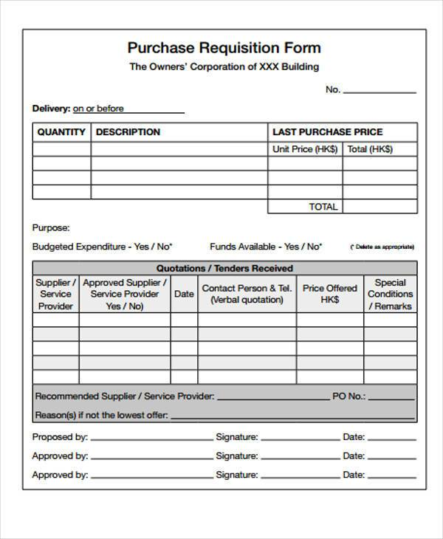
TENDER

- Tender is like quotations are invited by the buyers for the purchase of goods or servicesasking them to quote prices and terms and conditions.
- Tenders are invited through a notice or advertisements in the newspapers. It is an open invitation to all sellers or suppliers.
- Tenders are invited for the execution of a series of services or supply of products for a period of time usually a season or a year.
- Tender is invited for the supply of a bulk of goods.
- Tenders are more formal and very systematic requires several formalities.

Sealed tenders are confidential and are opened only on a particular day in the presence of tenders team.

A.P.POWER GENERATION CORPORATION LTD.,
Tender Notice

Specification No. ABC/18/2001

Sealed tenders are invited for supply of spares 400KW A.C. induction motors of 6.6KV KTPS’B.

Cost of tender specification is (non-refundable) Rs. 500/- by Demand Draft drawn in favour of General Manager APGENCO, Hyderabad.

Tender specifications can be had from the office of the superintending engineer, Vidyut Soudha, Hyderabad on all working days. Last date of receipt of Tender is on 14-4-2019 by 15.00 hrs. Date of opening of tenders at 15.00hr on 16/4/2019. Board is not responsible for any kind of postal delay.

Superintending Engineer

VidyuthSoudha
Hyderabad.

ORDERS
- Orders are the result of a chain of action and reaction between seller and the buyer to create a business transaction.
- A voluntary offer from the supplier/manufacturer of products or an informative advertisement may stimulate a potential buyer to write a letter of enquiry to gather some more details about the sale of that product. It results into prompt reply by the supplier, giving all possible answers to questions and doubts expressed in the letter of enquiry.
- It also furnishes some more related information along with price lists, brochures etc.
- A reply which satisfies the curious customer motivates him to place an order,
creating a legal/trade bond between them as shown in fig.
- An order may be an outcome of acceptance of the reply to the

B
U
Y
E
R

S
E
L
L
E
R
LEGAL
OFER

ORDER
ENQUIRY

TRADE
REPLY

Printed order form
- Large industries houses and big business firms use pre-printed order forms, which thy supply to the proposed buyers on their request or along with the reply letter.
- These order forms are prepared with standard and common conditions, terms and instructions to the user.

Order Form

ABC COMPANY LTD.

Date:
To
XYZ Company Ltd.,

Sir,
Sub: Supply of Appliance and Fitting.
Ref: Your Quotation No. Date

We are pleased to place the supply order for the following appliances and fittings.

S.No. | Product Code | Product Specification | Rate per unit in Rs. | Quantity in Nos. | Total amount in Rs.
1. | SD-2 | ABC | 500-00 | 50 | 25,000-00
2. | CD-5 | EFG | 100-00 | 100 | 10,000-00
 |  |  | TOTAL |  | 35,000-00

Signature:
ABC Company

COMPLAINT LETTER
- A letter of complaint is normally written to deal with a problem orsituation when other attempts have failed to rectify the situation.
- The complaint formalizes a problem situation by putting it into writing.
- Letter written to bring these mistakes to the notice of those who must own the responsibilities for them are called claim or complaint letters. So, when a letter is written to the seller by the buyer raising complaints or claims regarding mistakes taken place during the order to payment period is called a claim or complaint letter.

Sources of Complaint:
No business organization can declare itself error free as long as it operates with men, because to commit a mistake is a natural human act. Error may rise at any point; particularly it may be the following way: delay, wrong billing, defective packing, delivery of low grade goods, less quantity, etc. cause loss and inconvenience to the customer.

MARKETING
TRANSPORATION
UNLOADING
STOCKROOM
A/C SECTION
DISPATCH

LOADING
ON
VEHICLE

ORDER

PACKING

INWARD

BUYER

SALES

Fig: Source of Complaint

1. Buyer:Misunderstanding of reply or misinterpretation to terms or wrong calculation of discounts or assuming unsaid terms and condition ie generalization of terms.
2. Order: Code number which specifies quality may be wrong or any such minor fault may results into a mistake.
3. Inward section: clerk may commit a mistake or misplace it for someday or records its inward date wrong or any such error may occur.
4.Marketing department: they may send the letter to wrong section or keep the ordre idle.
5. Wrong entry of number or wrong packing.
6.Wrong Calculation: of bill by the counts department.
7. Damage of goods during transportation.

1. Courtesy, empathy, patience and positive tone are four principles to be followed strictly by the author.

2. A clear description of the mistake is to be given with total information to the supplier.

3. One can ask for rectification by sending back what he has asked for or cancel the order.

4. Avoid totally negative expression such as,’your mistake’, ‘your careless’, ‘you cannot understand the order’, etc.

Hints to Draft an Effective Complaint Letter:

Example:-
Sir,
I have ordered for 500 sheets of bond Paper A-4 sized and 500 Photostat papers of standard size 8^{1/2} / 13 inches on 1st March 2019. But I have received 500 sheets of duplicate papers and 250 sheets of ordinary paper on 15th March 2019. I am enclosing a photocopy of my order form and your catalogue for reference of date and particulars. I have also pinned a copy of receipt and acknowledgement of papers I have received.
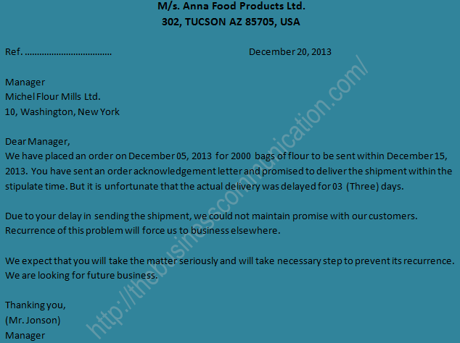

FOLLOW -UP LETTER

How to write Follow-Up Letter
Send it promptly. Wait a week or two after sending your job application. If you don’t hear back by then, consider sending a letter. Keep in mind that it will take at least a couple of days for the letter to get to the company. If you are in a rush, consider following up in a different way. You can also send an email, make a phone call, or even visit the office in person.
Be polite. Avoid accusing the employer of forgetting your application or ignoring you. Assume the best – that they are simply very busy and have not yet had time to read your application or respond to you. Be extremely polite throughout the letter.
Keep it short. The employer is likely very busy and has many applications to read through. Therefore, don’t add to his or her workload with a very long letter. Get right to the point, explaining who you are and why you are writing.
Reinforce your skills (briefly). While your letter should be short, you should briefly reiterate one or two things that make you stand out as a job candidate. Emphasize why you are right for the job, and/or the company.
Carefully edit and proofread your letter. This letter is a chance for you to make a first (or second) impression on the employer. Make sure it is professional and polished, and in proper business letter format. Read through the letter carefully before sending it.
Follow up again. If another week or so passes after sending your letter and you still haven’t heard back, you can send another. At that point, you might also follow up in a different way, such as a phone call or email.

Jane Doe
123 Main Street
Anytown, CA 12345
555-555-5555
jdoe@abcd.com
September 1, 2018
George Wyatt
XYZ Company
87 Delaware Road
Hatfield, CA 08065
Dear Mr. Wyatt,
I submitted a letter of application and a resume earlier this month for the programmer position advertised in the Times Union. To date, I have not heard from your office. I would like to confirm receipt of my application and reiterate my interest in the job.
I am very interested in working at XYZ Company, and I believe my skills and experience would be an ideal match for this position. In particular, my five years as an award-winning programmer at ABC Company make me a strong fit for this position and company.
Please let me know if you need any further materials from me.
I can be reached at (555) 555-5555 or jdoe@abcd.com. I look forward to hearing from you.
Thank you for your consideration.

Jane Doe

UNIT IV
Inter-departmental communication:
- internal memos,
- office circulars,
- office orders,
- office notes

Memo/memorandum:
- It is an internal administrative office communication device designed to transfer small messages, note or data between superior and a subordinate or group of subordinates, between sections in a formal organization.
- It transmits information about meetings, simple decisions, small departmental reports and personnel matters among colleagues or between head of departments and subordinates.
- Memos should be sent to a specific audience, depending on their purpose.
- Memos are used to keep employees informed on the latest happenings, either company-wide or in a specific department. For example, when management issues a change in corporate policy, a memo is used to explain the change.

Purpose of Memos:
Memos can be used to quickly communicate with a wide audience something brief but important, such as procedural changes, price increases, policy additions, meeting schedules, reminders for teams, or summaries of agreement terms, for example.
Memos are drafted for different needs
- For conveying routine messages among employees.
- To call for daily, weekly and monthly reports.
- If there is any slight change in the policy matters, regarding regular and common work conditions, the same will be informed through a memo.
- To call for explanation or to ask the staff to give account of an incident.

Drafting Memorandum

- Memos are interoffice communicating devices exclusively created to transfer administrative information among the employees.
- Several organizations use printed forms, to make it easy to the writer, to fill the blanks to convey the information.
- But though printed form is not suitable for all types of communication, such as when specific information is to be communicated.

How to Draft memos: -

1.Heading-
- Memos are written on letter head with the company name and its logo, along with heading.
- Immediately below the heading the name of the section of the department is written.

2.Name of the communicator & the receiver-
- Memos are exclusively for internal communication therefore, it is not necessary to include salutation.
- But it is important to incorporate the name of department/section/authority from where it has come and where it must reach.

3. Reference or file number-
- In printed form Ref no and file no are given either on right- or left-hand top corner and if it is written then it is necessary to mention the both.

4. Date –
- It is very important to write date on every memo.
- Date is useful for future references.

5. Subject Line-
- It is common to write the subject in a single and simple line to help the receiver understand the contents of the message quickly.

6.Message-
- Message is direct, simple and precise,
- Usually comprises of official language and terminology.

Chandra Rice Mill Ludhiana

Suppliers and exporters of Basmati rice
Office Correspondence

Ref. No. 15/8/P/WR Date : 15th March 2018

To-The Purchase Department,

From-General Manager Office

Sub: Weekly Report

The report to be submitted by the end of this week has not yet reached the statistical section of General manager Office. Kindly send it by evening so final report for general meeting can be prepared which is schedule on 17th March 2018 at 6p.m. in conference hall.
If extra time is required, then let me know by evening.

Signature.

OFFICE CIRCULAR-
- Office circulars are generally those letters which are circulated to a huge number of employees in an office in a simultaneous manner, conveying a special message or an instruction that needs to be followed in the future.
- It is user-friendly and a cost-effective method of circulating information by ensuring that the message reaches many persons at the same time.

Advantages of a circular
- Very simple and effective way of communication. Since it is precise and written, very little chance of miscommunication
- It is a cost-effective way of communication.
- Circulars are also a time-saving method. It reaches many people in very limited time and effort.
- They are great advertising and marketing tools as well. They can help create a new market, educate people about the product or services and increase consumer confidence in the company and the product.

Sample of a Circular
Circular No. ____
25th October 2018
Sub: Revised Working Hours
All Employees of XYZ Company,
This is to inform all employees there will be a change in the working hours of the organization effective immediately. As you know we now do not function on any Saturdays since last month. So we only have 5 working days in a week, a revision in the working hours was necessary to ensure the quality of work does not suffer. Hence one hour will be added to the previous 9 hour work days. The revised working hour will be as follows:
- Working Days: Monday to Friday (except holidays)
- Working Hours: 8:30 am to 6:30 pm (These hours will include the one-hour lunch break)
All employees are requested to note these new and revised timings. The timings are effective immediately from 26 October 2018. Punctuality and adherence to the new timings are requested. Repeated defaulters will face action. Please contact the HR department or your managers for any queries you may have.
ABC,
CEO of XYZ Company.

UNIT V
Oral/verbal communication skill:
Principles characteristics and structure of verbal communication, methods of verbal communication, speaking skills, telephone skills, deliberation/ presentation, negotiation skills, effective communication, body language.

The Verbal Communication is a type of oral communication wherein the message is transmitted through the spoken words. Here the sender gives words to his feelings, thoughts, ideas and opinions and expresses them in the form of speeches, discussions, presentations, and conversations.
- Any interaction that makes use of spoken words is considered as verbal communication. It is an integral part of the business world.
- Oral communication used within an organization includes personal discussions, staff meetings, telephone discourse, formal and informal conversations and presentations.
- The effectiveness of the verbal communication depends on the tone of the speaker, clarity of speech, volume, speed, body language and the quality of words used in the conversation.
- In the case of the verbal communication, the feedback is immediate since there are a simultaneous transmission and receipt of the message by the sender and receiver respectively.
- Main way of communicating faceto-face.
CHARACTERISTICS.
- Consider the objective.
- Think about the interest level of the receiver.
- Be sincere .
- Use simple language and familiar words.
- Be brief and precise.
- Avoid vagueness.
- Be polite.
- Allow time to respond

Types of verbal communication

1. Speaking face to face: here, our words are combined with our gestures, facial expressions and tone of voice to give a full communication package.
2. Speaking on the phone: communicating verbally on the phone is an excellent way to reach people far away.
3. Video-chat services: the wonders of the internet have enabled us to communicate verbally with people everywhere and to stay in touch with our loved ones across the globe.
4. Writing a letter: old fashioned letter writing is an art that will never die.
5. Giving a lecture: this is a key example of the utility of verbal communication in an academic context.
6. Making announcements: those handy announcements over the tannoy at supermarkets or train stations are key examples of verbal communication.
7. Leaving a voice mail: sometimes, we can record our verbal communications for our friends, family and colleagues to pick up later.

Methods of Verbal Communication

Verbal communication include sounds, words, language, and speech. Speaking is an effective way of communicating and helps in expressing our emotions in words. This form of communication is further classified into four types, which are:

1. Intrapersonal Communication
This form of communication is extremely private and restricted to ourselves. It includes the silent conversations we have with ourselves, wherein we juggle roles between the sender and receiver who are processing our thoughts and actions. This process of communication when analyzed can either be conveyed verbally to someone or stay confined as thoughts.

2. Interpersonal Communication
This form of communication takes place between two individuals and is thus a one-on-one conversation. Here, the two individuals involved will swap their roles of sender and receiver in order to communicate in a clearer manner.

3. Small Group Communication
This type of communication can take place only when there are more than two people involved. Here the number of people will be small enough to allow each participant to interact and converse with the rest. Press conferences, board meetings, and team meetings are examples of group communication. Unless a specific issue is being discussed, small group discussions can become chaotic and difficult to interpret by everybody. This lag in understanding information completely can result in miscommunication.

4. Public Communication
This type of communication takes place when one individual addresses a large gathering of people. Election campaigns and public speeches are example of this type of communication. In such cases, there is usually a single sender of information and several receivers who are being addressed.

Speaking Skills

Speaking is the delivery of language through the mouth. To speak, we create sounds using many parts of our body, including the lungs, vocal tract, vocal chords, tongue, teeth and lips.

Speaking is the second of the four language skills, which are:
- Listening
- Speaking
- Reading
- Writing
Speaking can be formal or informal:
- Informal speaking is typically used with family and friends, or people you know well.
- Formal speaking occurs in business or academic situations, or when meeting people for the first time.
Speaking is probably the language skill that most language learners wish to perfect as soon as possible. It used to be the only language skill that was difficult to practise online. This is no longer the case. English learners can practise speaking online using voice or video chat and services like Skype. They can also record and upload their voice for other people to listen to.
Speaking style means the tone, pitch, accent, volume and pace of your voice.
The same sentence can be conveyed, and understood, in entirely different ways based on the way in which it is said. People you speak to can be motivated by a positive speaking style, just as they can be put off by a negative style.
Speaking Skills:
Some speaking skills are:
1. Be prepared and practice. The more you know what you want to say, the better you'll get at it. First, brainstorm the topic of your speech and research it, if you need to. Write down all the points you want to make and then organize them into an outline. Then, practice your speech out loud at least 3 to 5 times.

2. Know your audience. The better you know your audience or listeners, the easier it will be to connect to them as you speak. When you are able to make that connection, you'll hold their attention.

3. Pay attention to the old KISS principle, that is, Keep It Short and Simple. When you are speaking don't beat around the bush or try to impress with complex metaphors. Stories, however, can be a powerful public speaking tool, especially when they contain at least a hint of humor. But again, keep them short and on point. Shorter messages leave more impression. They're also easier for your audience to remember.

4. Interact with your audience. Lectures will rarely have the same impact on an audience that an open discussion will. Look for opportunities to involve your audience in what you are speaking about. Ask for validation of points you are making ("Am I right?" "Has that ever happened to you?") Or allow time for questions. Also, make sure to establish eye contact with your audience, and keep it throughout your speech.

5. Speak with sincerity and passion. When a person wants to leave a lasting impression with the audience about one’s topic then be sure that you are true to yourself and your topic as you speak .Don't be afraid to inject enthusiasm and passion into the speech as well.

6. Close your speech in a memorable way. Give your audience something to think about as you finish up your speech. Certainly, it's a good idea to summarize your main points one more time, but then finish up with an inspiring story or quote, or leave them with a thought provoking question.

- Fluency The main goal is fluency. Remember that one don't have to know many complex grammatical structures to achieve that goal! First of all try to speak as fluent as possible (even making some grammar mistakes). Then, after making one’s speaking fluent, one can focus on grammar aspects.

Presentation/Deliberation

- Presentation means speaking to listener or group of listeners with duly prepared lecture, which suitable to listener and the objectives of the related subject.
- It is very important that the presentation of the matter should be effective and must be suitable to listener, keeping in view the nature and circumstances that influence the listener.
Presentation can be divided into two parts:

Individual Group presentation
presentation

- resenting new commodities/service /system.
- Construct model/layout/policy.
- Entertainment of participants/audience and others.
- Selling products/services/concepts/thoughts or ideas.
- Suggestion about any solution, problems or new concepts.

Objectives
of Presentation

Kinds of Presentation

Presentation can be divided in the following kinds as per its objectives:

    - Informative presentation -refers to giving information to audience about some event or subject.
    - Persuasive Presentation- refers as to how persuade the audience to do or perform some work like following or accepting some specific behavior.
    - Goodwill Presentation- refers to earn the goodwill of audience at a time or in a specific situation.

Stages of Effective Presentation

Main Principles of Oral Presentation

Friendliness
Sincerity
Confidence
Attention

Purpose of presentation

Subject

Clear language

Persuade Relation between
Main subject &
&familiar subject.
Entertainment

Analysis

Building of Credibility
Pre-viewing of presentation
Development of main idea
Research
Arousing Interest
Emphasising Structure
Ending

Negotiation Skills

- Negotiation comes from the Latin neg (no) and otsia (leisure) referring to businessmen who, unlike the patricians, had no leisure time in their industriousness;
- Negotiation is the process of conferring to arrive at an Agreement Between different parties ,each with their own interest and Preference
- A give and take decision making process involving interdependent parties with different Preferences.
- Negotiation is a process of bargaining in which two parties, each of which has something that the other wants, try to reach an agreement on mutually accepted terms.
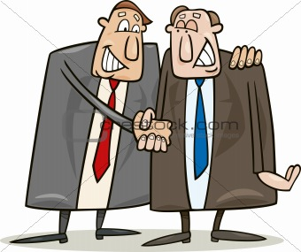
The Oxford Dictionary of Business English defines negotiation as;
a. ‘a process of trying to reach an agreement through discussion.’
b. ‘a meeting where this discussion takes place’

Factors Affecting Negotiation
The factors usually affect the outcomes of negotiation-

Four principles of best practice Negotiation

• Preparation:- understanding the issues and the people and equipping the team for the process
• Relationship:- developing a strategy for maintaining the relationship before, during and after negotiations
• Communication:- building trust by applying an open communication style
• Problem-solving:- exploring options and strategies for reaching agreement

Features Of Negotiation
- Two parties
- Pre-determined goals
- Expecting an outcome
- Parties willing to modify their position.
- Parties should understand the purpose of negotiation.

Types of Negotiation

- Distributive Negotiation–
- The most distributive feature is that it operates under a zero sum game.
- The gain may be made by one person is loss incurred by the other person.
- Each person involved in the negotiation defines ultimate point where the settlement may be made.
- Win-lose situation.

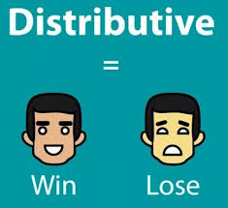

- Integrative Negotiation
- Parties cooperate to achieve maximize benefits by integrating their interest.
- Both patties involved in negotiation process jointly look at the problem and try to search for alternatives and try to evaluate them and reach mutually acceptable decision.
- Win-win situation

STAGES IN THE NEGOTIATION PROCESS

1. The preparation Phase- There is two aspects in which the negotiator has to be prepared before the negotiation:
- Assessing the relative strength of the two parties.
- Setting negotiating objectives. At this stage, the negotiator should try to answer the following questions:
i. what are the real issues?
ii. Which parties should be involved?
- That he/she is clear about the desired goal of the discussion.
Negotiators should be realistic about their objectives. If the deal is not achievable, they should be prepared to lower their expectations.
2. The Negotiation Phase-
Most effective negotiations follow a set sequence:
- The parties begin by defining the issues at hand.
- After that comes a more open phase in which the initial positions are tested through arguments.
- The parties then move to discussing a possible solution that could result in a resolution.
- Firm proposals in more specific terms are then discussed and modified before both parties accept them.
- Finally, an agreement is spelled out and a conclusion is reached.
3. The Implementation Phase-
This constitute two basic phases of the actual process of negotiation-
- One before initiating the negotiation process.
- After concluding discussions.

TELEPHONE/CELLPHONE ETIQUETTE

In telephone conversations, the way we listen, respond, speak or hang up is often as important as what is communicated.
Making a Call
Before initiating a call, be clear about the why and what of the call, how to begin the call and what to do if the call is cut off.
Prepare Before Calling
- To be brief and concise, jot down the points one want to discuss.
- Keep a notepad and pen ready to write down any information worth recording.
- Keep conversation as short as possible.
- Calling a cell phone from a landline number should be avoided as it may give the impression to the receiver that you re taking their availability for granted.

How to Begin or receive a Call
- The first few words spoken by the caller or receiver are important for establishing identities and the purpose of the call.
- They create the context for further conversation.
- One should be patient and pleasant while dealing with the important link between the caller and the desired contact person.
If the Call is Disconnected
- In such situations, courtesy demands that the person who originally initiated the call should redial immediately and say “Sorry, the call got disconnected”.
Common Telephone Courtesies
Always use the interrogative form for making a request, such as “Could I…..” or “May I….” as Direct categorical statements may seem like an order.
Telephone Etiquette Observed by Administrative Assistants
In business, telephone calls are mostly received by personal assistants. Sometimes the assistant has to act quickly to find out whether his or her supervisor is free to talk or not, so they may say, ‘Please hold on’.
Telephone Precautions
- Avoid discussing confidential matters as they can be overheard/tapped in transmission.
- Communication over the phone requires the use of non- verbal skills , such as pleasant tone, proper intonation and clear articulation of words.

Body language

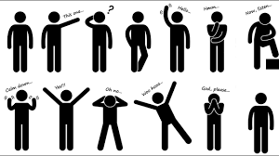

This is a form of non-verbal communication for which George Terry has given a term ‘Body Language’.
Body language is a type of nonverbal communication in which physical behaviors, as opposed to words, are used to express or convey information. Such behavior includes facial expressions, body posture, gestures, eye movement, touch and the use of space.
- It includes twinkling of eyes.
- Biting and moving lips.
- Clapping and other movement of hands.
- Nodding of head.
Types of body language

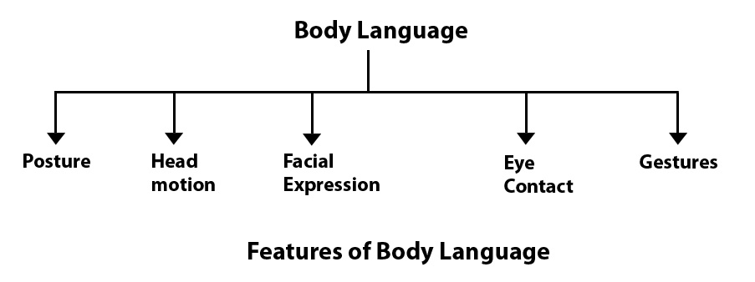
Physical Appearance

  - Posture
The way a person stands or sits is his posture. It is good to adopt a flexible erect posture rather than a stiff or slouching posture. An erect posture reveals confidence and poise. Drooping shoulders, sagging in the seat, etc., reveal a feeling of depression and lack of interest.
  - Head motion
In oral communication, the movement of the head plays an important role. No one is expected to keep on shaking his head, but appropriate nods and shakes of the head enhance the level of communication.
  - Facial Expression
- It is an important part of body language. Face clearly transmit the messages whether the person is engrossed in thinking or otherwise.
- Facial expression conveys happiness, anger, fear, depressions or dejection.

  - Eye Contact
- In an oral communication context, the speaker and listener should not only face each other but also maintain correct eye contact.
- If someone avoids direct eye contact, he is suspected to be sly or cunning.
- In eastern countries, subordinates or younger people may avoid direct eye contact out of respect or deference, but it will be misunderstood in an international context.

  - Gestures
- Are related to the movements of hands, legs, arms ,torso and head.
- Hands, arms, legs and head movements communicate important messages without words.
- But, gestures are culture specific. A clenched fist may mean emphasis for an American but disrespect for an Indian. A thumbs up sign, a movement of the index finger communicate messages effectively.

  - Bodily Contact
- Pushing, holding, tabbing, hugging, shaking hands, embracing etc are include in bodily contact.
- Bodily contact is a primary form of communication.
- The way you place your body and arms and legs, in relation to each other, and in relation to other people:
  - Body proximity - How far or close to other people.
  - Shoulder movements - Up, down, hanging, hunched.
  - Arm placement - up, down, crossed, straight.
  - Leg and feet placement - straight, crossed, weight placement, feet towards speaking partner or pointing elsewhere, dangling of shoes.
  - Physical Appearance
- It is the hair style, suitable facial makeup, dress, colour and design of clothing, shoes etc.
- Dress must always be convenient and matching to the personality.

Advantages of Body language
  - It is helpful in receiving and decoding of a message.
  - It assists verbal communication .infact, without body movements face to face communication can not be much effective.
  - Proper application of body language makes the atmosphere of a business unit.
  - This type of communication use gestures, facial expressions, eye contact, proximity, touching etc. and without using any spoken or written word. So, it is very much helpful for illiterate people
  - Non-verbal communication is based on visual, picture, graph, sign etc. that can be seen very much attractive.
  - Non-verbal cues of communication like sign and symbol can also communicate some messages very quickly than written or oral messages.
  - Non-verbal cues of communication greatly help in handicapped people especially to deaf people. Deaf people exchange message through the movements of hands, fingers, eyeball etc.
  - Non-verbal message may substitute for the verbal message especially if it is blocked by noise, interruption, long distance etc. for example; gestures-finger to lips to indicate need for quite, facial expressions- a nod instead of a yes.
Disadvantages of Body language
- Vague and imprecise: Non-verbal communication is quite vague and imprecise. Since in this communication, there is no use of words or language which expresses clear meaning to the receiver. No dictionary can accurately classify them. Their meaning varies not only by culture and context but by the degree of intention.
- Continuous: It is possible to stop talking in verbal communication, but it is generally not possible to stop nonverbal cues. Also, spoken language has a structure that makes it easier to tell when a subject has changed, for instance, or to analyze its grammar. Nonverbal does not lend itself to this kind of analysis.
- Multi-channel: while watching someone’s eyes, you may miss something significant in a hand gesture. Everything is happening at once and therefore it may be confusing to try to keep up with everything. Most of us simply do not do so, at least not consciously.
- Culture-bound: Non-verbal communication is learnt in childhood, passed on to you by your parents and others with whom you associate. A few other gestures seem to be universal. Evidence suggests that humans of all cultures smile when happy and frown when unhappy. However, most nonverbal symbols seem to be even further disconnected from any “essential meaning” than verbal symbols. Gestures seen as positive in one culture (Like the thumbs-up gesture in the USA) may be seen as obscene in another culture.
- Long conversations are not possible: In non-verbal communication, long conversation and necessary explanations are not possible. No party can discuss the particular issues of the messages.
- Difficult to understand: Difficult to understand and requires a lot of repetitions in non-verbal communication. Since it uses gestures, facial expressions eye contact, touch etc. for communicating with others which may not be understandable for the simple and foolish people.
- Not everybody prefers: Everybody does not prefer to communicate through non-verbal communication with others. Sometimes it cannot create an impression upon people or listeners. It is less influential and cannot be used everywhere. It is cannot be used as a public tool for communication.
- Lack of formality: Non-verbal communication does not follow any rules, formality or structure like other communication. Most of the cases people unconsciously and habitually engaged in non-verbal communication by moving the various parts of the body.
- Costly: In some cases non-verbal communication involves huge cost. For example, neon sign, power point presentation, cinema etc are very much costly compared to others form of communication.
- Distortion of information: Since it uses gestures, facial expressions, eye contact, touch, sign, sound, paralanguage etc. for communicating with others, there is a great possibility in distortion of information in non-verbal communication.

How to make body language effective

- Every communicator must try to build a very pleasant personality, through change in behaviour, thoughts and approaches.
- Regulate body language by observing and controlling expression gestures and body movement.
- Pleasant smile, graceful movements and positive attitude help a person to win others in interviews or at work place. But never put plastic smile which receiver can detect immediately and under grade the communicator.
- Totally avoid unnatural, rigid and uncomfortable postures and gestures.

Positive body gesturesNegative body gestures
Positive body gestures are a sign of confidence and security. They are a sign of active participation and leave a good impression. Positive gestures include: -
- Walking upright
- Shaking hands confidently
- Having a pleasant face.
- Nodding head is a positive gesture
- A steady eye contacts

Following negative gestures are a sign of insecurity and restlessness. Such gestures show a lack of confidence. Such gestures should be avoided in interviews or meetings.
- Being up tied
- Biting nails
- Getting distracted
- Faking a smile
- Looking at something else while talking instead of the speaker
- Proper etiquettes should be followed.

